Krzysztof ZIOLEK

Who wants to be a millionaire

66513, The Commonweal School

Contents

Analysis 3

Introduction 4

Research on the project 4

Background to/identification of the problem 4

Description of the current system 5

Lifelines 5

Taking the money 5

Wrong answer 6

Basic algorithm of the game 6

Different versions of the game 7

Identification of prospective users 8

User needs 8

Acceptable limitations 8

Data sources 8

Data volumes 9

Complexities 9

Data dictionary 10

Objectives 10

Chosen Solution 11

Questionnaire 12

Design 15

System design 15

Modular design 16

Data validation 17

Overall Test Strategy 17

Black-box Testing 17

White-box Testing 17

Flow Diagram 17

Pseudo Code 18

Database design 41

UserPass 41

Leaderboard 42

LifelinesUsed 43

Validation/Verification 44

Validation and verification in my project 44

SMART Targets 47

Technical Solution 47

Evidence of SMART Targets in the program 47

Demonstration of complexity 54

Group A 54

Group B 54

Group C 54

The whole solution 54

Testing 54

Basic tests: 54

General testing 54

Known issues 54

User experience 54

Evaluation 54

# Analysis

## Introduction

Who Wants To Be a Millionaire is game/game show that has been going on for over 20 years now, it is a great fun show that challenges contestations with 15 multiple choice questions and the grand prize being 1 million pounds. There are also other cash prizes to be won if the contestant wishes to stop playing and keep the money they have already won through answering the questions correctly, there are no second chances, the game is very unforgiving as one wrong answer ends the game completely. The game also traditionally contains 3 lifelines and most recently the addition of a 4th lifeline, the lifelines are ; phone a friend, ask the audience, 50/50 and ask the host. The contestant can use their lifelines to help answer the questions, when they use one lifeline it is no longer available for them to use again. The reason I want to recreate this game for my project is because I enjoy the concept and would love to create this game for users to play as a program. It is also competitive with others as people are more knowledgeable in different areas so it really brings out the trivial part of everyone. I have also wanted to implement a leaderboard system which allows users to compare their scores with others, also making the game more competitive (despite there being no real money involved).

## Research on the project

My research was mainly on how I can recreate the real game in a computer program, also on how I can implement a leaderboard system along with the game. My main concern was actually getting enough questions as I couldn’t just ask the same questions every time because returning users would figure out the answers after a few tries and eventually everyone would be winning. I decided on taking realistic questions and the real answers to the questions, then I will put the questions and the answers in a list which will be indexed by question and then there will be 10 different questions per questions number. For example, questions 1 will be a random question out of 10 questions that I will write and so on. To make a leaerboard from all the users that have played I figured the best way to store that data will be using a database, so for this I will use SQLite where I will make a relational database for the scores and how many lifelines were used, however this gave me a second question, how will I identify what user got what score? So, I personally decided to add a login system which includes a username and password so each time the user wants to play they have to login with their account so the data that they generate (scores, lifelines used etc) are stored in the database under their name where it can be compared with others.

The login system will detect if the username already exists so there will be no duplicate usernames and therefore there will be no confusion with results, I researched that the best way to display data in a leaderboard type way is by using pandas, this will help me print out the data to the user in a very user-friendly and understandable way. I also want to add another statistical element into the game, I want to do this by using an aggregate SQL function called “AVG”, this gets the average of a set of values[1]. Then, I would use the users score and compare it with the average of all the other scores so the user can make an easier judgement of how well or how bad they did comparing to others. To make the graph I will use the MatPlotLib module, I researched how to graph in Python and found out that using the MatPlotLib module is the best way to do what I would like to do.

## Background to/identification of the problem

My project is aiming to recreate Who Wants To Be a Millionaire and adding multiple features which in my opinion make it more fun and competitive for people who are playing it online, the reason I want to do this is to compare different users scores, I have seen the real WWTBAM and I enjoy the tension that it creates, however we never get to see how each person stacks up against each other and I want to change this which brings me to my statistical approach of leaderboard and graphs along with a login system.

Showing the user how they compare to the average as well how they compare to other users gives them a more accurate representation of how they actually did, rather than them having to figure out whether they are happy with their result or not. The main problem im trying to fix is providing the user a visual way of viewing their scores which removes confusion at the end of the game if they get a question wrong or just wondering how they stack up compared to others.

## Description of the current system

Who Wants To Be a Millionaire is actually a game with a simple concept, answer 15 questions correctly and you will win 1 million pounds, however diving a bit deeper there are a few more variables that we need to be aware off, these are:

* Lifelines
* Being able to take the money if you don’t know the answer
* Getting a question wrong

### Lifelines

The variables that make the game more exciting than just seeing if the contestant answers right or wrong are lifelines, these are potential life-savers for contestants (hence the name lifelines) as they can provide the answer to a question that the contestant may not know the answer to. In the most recent version of WWTBAM there are 4 lifelines; phone a friend, 50/50, ask the audience and the newest addition, ask the host.

In the past, these have been used by many to elevate the amount of prize money won however also can create drama, an example of this is the ‘phone a friend’ lifeline which allows the contestant call a friend/relative to help them with the question they are stuck on. This can be a very useful tool as the person on the other end of the call may have knowledge in an area that the contestant doesn’t therefore helping the contestant answer the question correctly, however this can also work the other way where the ‘friend’ can confuse the contestant more with their answer or they may not even know the answer themselves, which in essence is wasting a lifeline and makes it a risky lifeline to use.

### Taking the money

The main concept of the game is obviously to go as far as possible and win the million-pound prize, however contestants are allowed to just take the money they have already won and end the game with that amount, the reason someone may do this is because they don’t know the answer to a question and are out of lifelines or they could be happy with how much they have already achieved to win and don’t want to take the risk of losing it all so therefore leave with the money.

In the real game there are also ‘safety nets’, what this means is that once the contestant passes a certain question they can't lose all their money and they leave with the safety net amount. The first safety net is set at question 5 (£1000), so if the contestant gets 7 questions right for example and the 8th answer is wrong, they would leave with £1000. The second safety net was traditionally set at question 10 (£32,000), this would give the incentive to go further in the game and would give the contestant a ‘free hit’ for £64,000 as even if they got the answer wrong, they would still leave with ££32,000. However, in the most recent version of the game the 2nd safety net can be decided by the contestant and they can set it wherever they feel comfortable between question 6 and question 14. It is a real balance between risk and reward as if you set the lifeline to early you are more at risk for losing out in the latter stages of the game if you do go far, likewise if you set it too late you may lose out before you even get to that stage and therefore go home with a prize much less than it could have been.

### Wrong answer

Only 6 people have won the jackpot in Who Wants To Be a Millionaire[2], this means that in the 20+ years of the show airing most people ‘lose’ and don’t claim the ultimate prize. This shows that chances are you will not ‘win’ and get the ultimate jackpot as it is extremely hard and not only requires a lot of knowledge but also some luck on your side. However, just because someone answered wrong doesn’t mean they have totally lost, this is because they still get to take home money with them and that can be worth a lot to them so in a way they have ‘lost’ cause they didn’t get to the ultimate goal but they can still ‘win’ in their own sense by taking money that will help them.

### Basic algorithm of the game

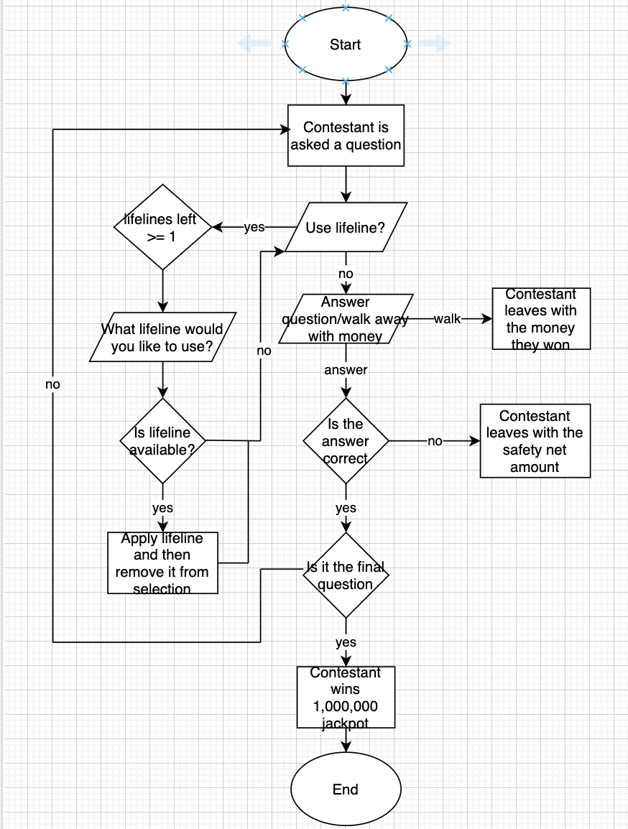

### Different versions of the game

I am aiming to recreate the original version of the game which was based in the UK originally, however over the years the show has been changed in different countries and more variables have been added to seemingly make it harder for the contestant but likewise potentially more entertaining to watch.

In 2008 the US version of the game introduced a clock format to the game, this meant that the contestant had to answer the question in a set amount of time, the time depended on what question the contestant was on so this varied:

* Question 1-5 = 15 seconds
* Question 6-10 = 30 seconds
* Question 11-14 = 45 seconds
* Question 15 = 45 seconds (plus any time left over from the previous questions)

If the clock ran out then the contestant would walk away with the amount of money they had won and that would be it, the time would start after the question and 4 answers were read out however it would be paused when a lifeline was used.[3]

In another version of the game there was a ‘shuffle format’ introduced where the game was split into 2 different parts for the contestant. The first round was a set of 10 questions and it was completely randomised in terms of question difficulty/category and cash prize associated with that question, therefore the contestant doesn’t know how much the question is worth unless they answer the question correctly or choose to walk away. If the question is answered correctly the money is banked and the next question is asked, if the contestant decided to walk away at this stage they would leave with half of the money that was banked. However, if the contestant gave a wrong answer they would just leave with $1000.

If the participant made it through the first round, the second round was based on the original format of the show so that means questions go back to general knowledge and feature high cash prizes. Now if the contestant wanted to walk away they would take the full banked amount from the previous round, or if the participant played on and they got a question wrong they would get $25,000.

## Identification of prospective users

The user of this program would be people who enjoy trivia/question type games and people who want to challenge themselves and their general knowledge. This is a game meant for enjoyment and for being competitive against other users to see who can get the highest score. The game will only accept one user to play at a time, this is because of the login system put in place to ensure the leaderboard is accurate and that results are logged correctly.

## User needs

Me and my users need my program to:

* Accept login inputs (creating account/logging back in)
* See the leaderboard
* View the graph showing the average scores compared to their own
* Accept answer inputs
* Accept lifeline inputs

## Acceptable limitations

Limitations:

* Not including the ‘ask the audience’ or ‘ask the host’ lifelines
* No host commentary (like in the real show)
* There is not an endless amount of questions
* The user not being able to just ‘take the money’ and walk away

## Data sources

The data movement in this program can be followed as all of the steps are always in the sane order, the only thing that can differ is whether the user already has an account or not. The program accepts the users login or new account depending on which they choose, they will then be taken to the game which is played until the user answers all questions correctly or gets a question wrong. Then, if user is an existing user they will be asked if they wish to update their previous score to the one they just got or keep the old one, new users will not be asked this as there is no previous score to update. This score is then plugged into the database using SQLite, the login information makes finding the right user very easy and since there can’t be two users with the same username the scores will not be wrongly assigned to the wrong account. The last thing the user will be asked is if they want to see the leaderboard, if they do they will be shown the entire leaderboard ordered from highest score to lowest. Other features in the menu include viewing the leaderboard and the graph showing your score vs. the average (you will need to login for this).

|  |  |  |
| --- | --- | --- |
| **Data** | **Source** | **Destination** |
| Username/Password | User | Database/Game |
| Question answers | User | Game |
| Game results going into database | Game | Database |
| Data from database going into leaderboard | Database | Leaderboard |
| Graph Visualisation | Database | Output to user |
| Leaderboard display | Leaderboard | Output to user |

## Data volumes

My project doesn’t rely on big data to work properly, the only long term data being stored is the user’s username, password and scores (money won, prize money, lifelines used etc). However, the scores part of the data will be used to form the leaderboard and the graph so although not a lot of data is stored it is still very important to store correctly. This data also stays there so it can be compared to others, this means that the more people that play the game and save their data, the more data there will be in total as there will be more data in the database.

## Complexities

In my program I plan to use Object Oriented Programming as it is much more useful compared to procedural programming, this is because I am planning this program out and giving it a proper structure not just thinking of ideas whilst coding. Object Oriented Programming also allows me to debug and execute the code in a cleaner more efficient way, classes also provide a better structure to the code as multiple instances can be created.

For my database I will be using SQLite as I think this is the best way to store, compare and transfer the data to a graph so the user can see it. It also is the best way to organise this data as there will be a lot of it, if this data goes straight to the database it will keep the program clean for the user and it will be more organised.

For my graph to visualise the data for the user I will be using Matplotlib, this is so it is easier for the user to understand how their result compares to an average of all the other results. The user will easily be able to judge how well they have done compared to other people, there is also the option of just viewing the leaderboard as well.

For my leaderboard I will be using pandas, this is the best way to present a table in my opinion from the research I have done. Pandas makes it a lot easier for me to display this data as I can just take the data from the database and put it into a separate dictionary, pandas will then format the data for me making it very friendly for the user to look at.

## Data dictionary

|  |  |  |  |  |  |
| --- | --- | --- | --- | --- | --- |
| Name | Purpose | Type | Size | Example | Validation |
| Username | This is needed for the login and so the users result can be logged correctly | String | 1 | ‘Kris’ | If there wasn’t a username the result the user got would not be tracked properly |
| Password | The login system needs these so users can make sure their accounts are secure to them | String | 1 | 'SGh3uWkz’ | I want all users to have a password so that they know their account is secure and nobody could just go change their score |
| SQLite  database | The login data and all the data from the results of the game will be stored in this database | String/  integer | No specified amount | Username: ‘zkr5152’  Score: 5  Money Won: £1000 | All data needs to be stored and using a database is the best idea for this especially because it needs to be stored long term. |

## Objectives

* The program should accept a returning user
* The program should let the user create a new account
* The program should detect if the user is trying to create a new account with a username that already exists
* A leaderboard should be made showing all the users and the scores going from highest to lowest
* A leaderboard should be made showing all the users and how many lifelines they used from lowest to highest
* A graph should show the average score for users compared to the user that is playing
* Data from the results of the game should be transferred to the right tables in the database
* Users passwords should be encrypted before going into the database
* All lifelines should be available (50/50 and call a friend)

I would like to make the program as user friendly and as fun as possible, this is a game that is meant to be enjoyed so I want the user to be comfortable with working the program. To play the game the user will have to login or make an account, this shouldn’t take long unless the user has issues with remembering their username/password or choosing a username that already exists when making a new account. How fast the game is completed really depends on the user and how long they take to answer questions and how far they go. However, when it comes to data being moved from the program to the database and from the database to the leaderboard/graph it should be very quick and easy for the user to access.

## Chosen Solution

For my project I am going to use Python for my main program along with SQL to access my database and so I can insert\update data into it. Another module I will be using is Pandas, this is to format and display my leaderboard to the user, I will still have to retrieve the data from the database and process through it before I use pandas to format it.

The graph will be created using data from the database and then formatted using MatPlotLib, this is the best way to create the graph as I already have the data and just need formatting which this module does very well and therefore the user will clearly see how their score compares to the average.

## Questionnaire

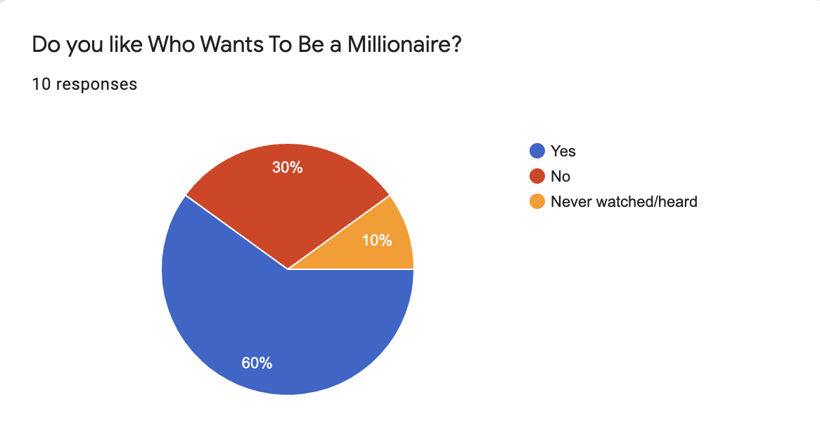

60% answered that they liked WWTBAM, this is a majority of the sample and shows me that most people like this game. This is good for me as users will want to continue to play the game and create more data. Although 30% said they don’t like the game, it still means 90% of the sample know about the game. This is a benefit to me as certain features in my program may interest the 30% more.

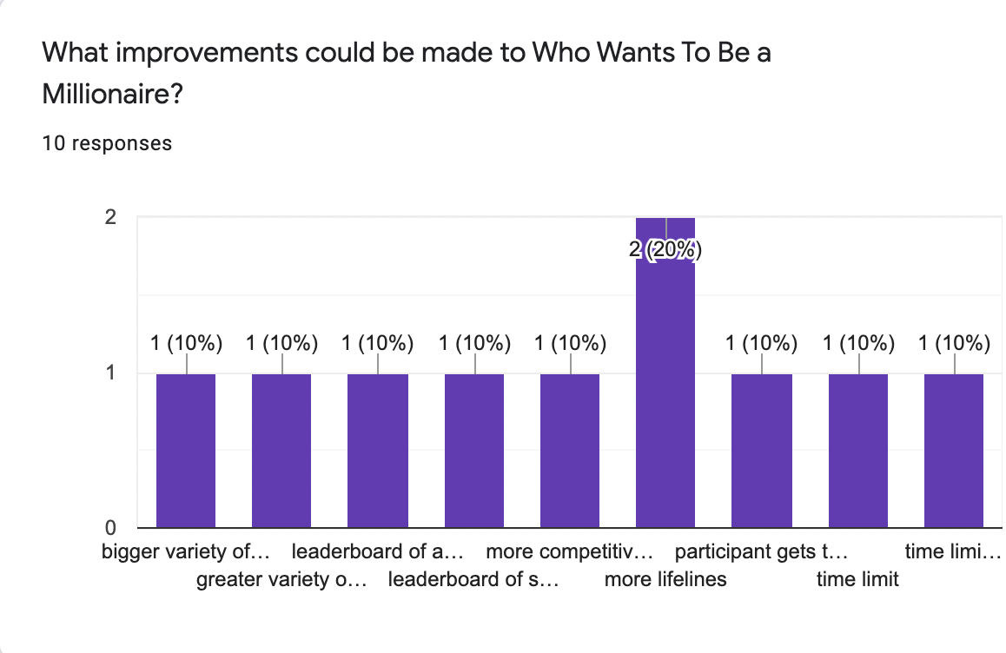

Most answers said they would introduce more/a greater variety of lifelines, in the real game there are already 4 (latest version) which is one greater than the original which had 3. More lifelines would be hard to implement just because what else can you give to the user that will help them but not reveal the answer? The leaderboard was also a popular choice which is what I will be implementing in my program, this increases competitiveness and keeps record of past users and their results. A time limit would add more pressure but it may deviate from the original concept of the game too much.

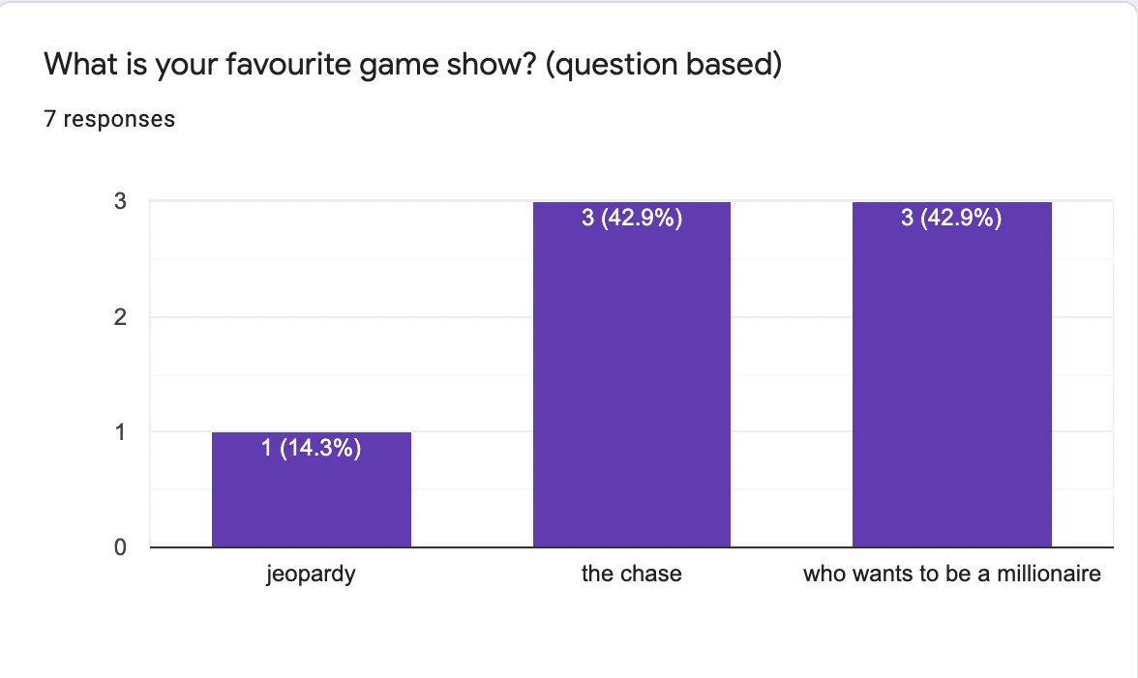

This question did not require an answer therefore got less responses than the other questions. This question's purpose was to see what other interests users had in terms of game shows, WWTBAM was tied with The Chase, and this shows me both games generate interest. Questions like what does The Chase do that WWTBAM does not?

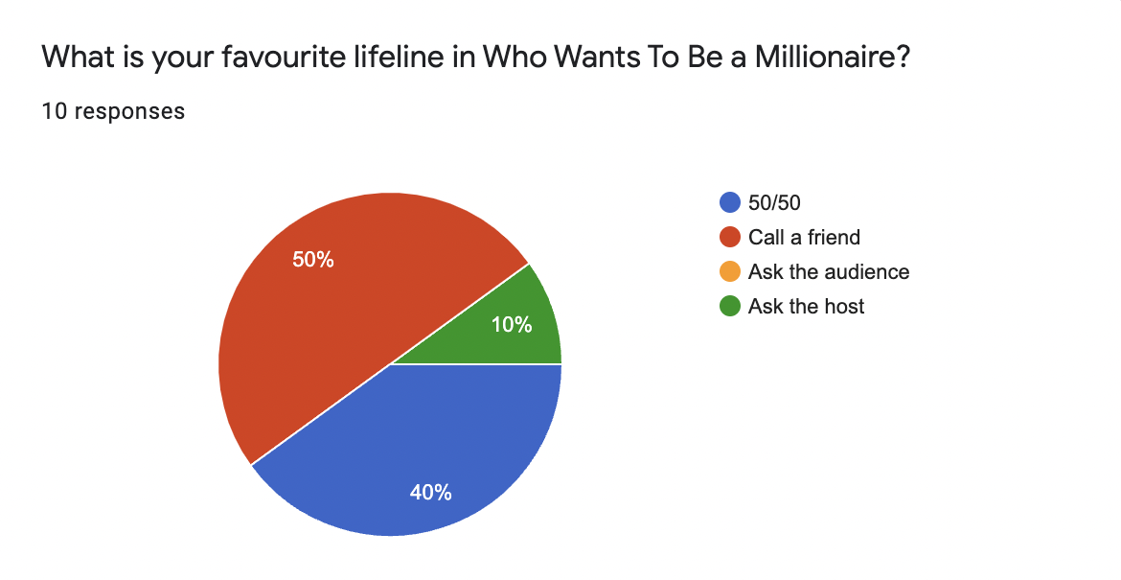

The answers to this question show that the call a friend and 50/50 lifeline are the most popular, this is positive for me as they are the two lifelines I am trying to implement in my program so this means users are most likely going to enjoy these in the program whilst playing the game. Ask the host would be tough to implement in my program as there is no real host, it is just the user being asked questions on the screen, so having an ask the host lifeline wouldn’t make much sense.

# Design

My code will be completed in separate stages, but I hope to stay as chronological as possible to avoid confusion with where data is going, the order will look like; menu, login, game, database, leaderboard, graph, other. It would be unrealistic to assume I wouldn’t have to go back to different parts to fix certain issues or just simply make something better however I will try stick to that order as much as possible. Completing all these stages in this order also makes it easier to link them all correctly as for example the leaderboard won’t work without the database but the game can work without the database and so on.

Firstly, I want to make sure the user can login correctly as this is very important to identifying them on the leaderboard, once this connection is made the game can be created and take inputs from the user (answers/lifeline use). When these 2 connections are established, the database is ready to be made and store the data that the game part of the program produces. The data will be stored in different tables inside the database, this is so all the data is easier to read and later use in a leaderboard. After the data is in the database it will be processed by the program and formatted into a leaderboard or graph.

## System design

Inputs – Username, password, answers to questions in the game, if the user wants to use a lifeline

Processes – the login data going into the database, scores/outcomes of the game for the user going into the database, data from the database going back to the program for the leaderboard, data going from the database back to the program for the leaderboard

Storage – the database will store everything I need, this includes; login (username/password), UserID, scores, money won and how many lifelines were used by each user.

Output – the program will output things to do with the login/game like for example if the user enters a wrong password, login will not be allowed. However, the main outputs will be the leaderboard and graph at the end which will be the biggest visualisation to the user.

|  |  |  |  |
| --- | --- | --- | --- |
| Input | Processes | Storage | Output |
| Username | Sets the username for the user of the program | Database stores the username |  |
| Password | Sets the password for the user of the program | Database stores the password |  |
| Answer to questions | The user gives an answer to the question and see if they are correct | The end score will be stored in the database so it can be used in the leaderboard at the end | The game continues if the answer is correct and ends if it is wrong |
| User using a lifeline | During the game the user will be asked whether they need to use a lifeline | If the user uses a lifeline it will be added to the lifeline count in the database | If the user decides to use a lifeline, it will be shown during the game |

## Modular design

* Main menu
* Start API
* User inputs Twitter account
* User inputs amount of tweets they wish to use
* Tweets are retrieved from the Twitter account
* Tweets put into SQL database
* View database
  + Tweets put into database (username, tweet, keyword)
* User chooses if they want to see the database or not
* If yes, the database comes up
* If no, the user will be directed to the visualisation stage
* View graph of keywords
  + Graph is made of keyword frequency (most common)
    - View suggestion
      * A suggestion is made on Twitter depending on the users keywords
      * If yes, show suggestion
      * If no, return to main menu
    - Quit
* Main Menu
* Start Game
  + User logs in or creates new account if they need to
  + If login is accepted the game will start
  + The game keep going until the user gets a question wrong or wins the ultimate prize of 1 million pounds
  + The user will have a choice of 2 lifelines they can use, each of them they can use twice
  + When the game ends the user will be asked if they want to see the leaderboard
* View Leaderboard/Graph
  + The user will be asked what leaderboard they want to see (leaderboard based on highest score/leaderboard on lifelines used)
  + The user will also be able to see the graph that shows their score compared to the average
* Quit

## Data validation

If the user is trying to login with an invalid username/password (doesn’t exist/doesn’t match previous records) then the program will reject entry for the user, it will ask the user to either enter the details again or make a new account if they can’t log back in. There is also no access to the game without an account so if a user can’t remember their old login they will have to make a new account.

If the user enters an invalid input in the game (invalid answer/request) the program will ask for a valid input from the user until it gets one, so the user can enter a wrong answer as many times as they want but they won’t be able to continue the game or the rest of the program.e

## Overall Test Strategy

This game is relatively easy to test, the login system can be checked with valid and invalid accounts and credentials, the game itself is questions and answers so the test strategy would be to give right answers but also wrong ones to see if the outputs are correct. The database would also have to be checked if usernames/passwords and results are going into the correct areas.

### Black-box Testing

Black-box testing means hiding the actual system code from the tester and not telling them what to test specifically but rather just a general test. There is only one way to play WWTBAM so testing should not be too hard to complete and see if there are any problems with the system. The tester will simply act as a new user for the first time, their results will be stored in the database as normal if everything works correctly, after the first attempt the user can act as an existing user because they will already have an account that they can use.

### White-box Testing

White-box testing tests how the program works systematically and it checks the functionality of the system. To do this I will try isolate parts of the algorithm (mainly the game part) so that they can be tested individually, this will highlight any problems specifically in the system and they will be easier to identify as the algorithm will be split up into different parts. Various inputs can be used to see how the system reacts and how it functions to show the correct output.

## Flow Diagram

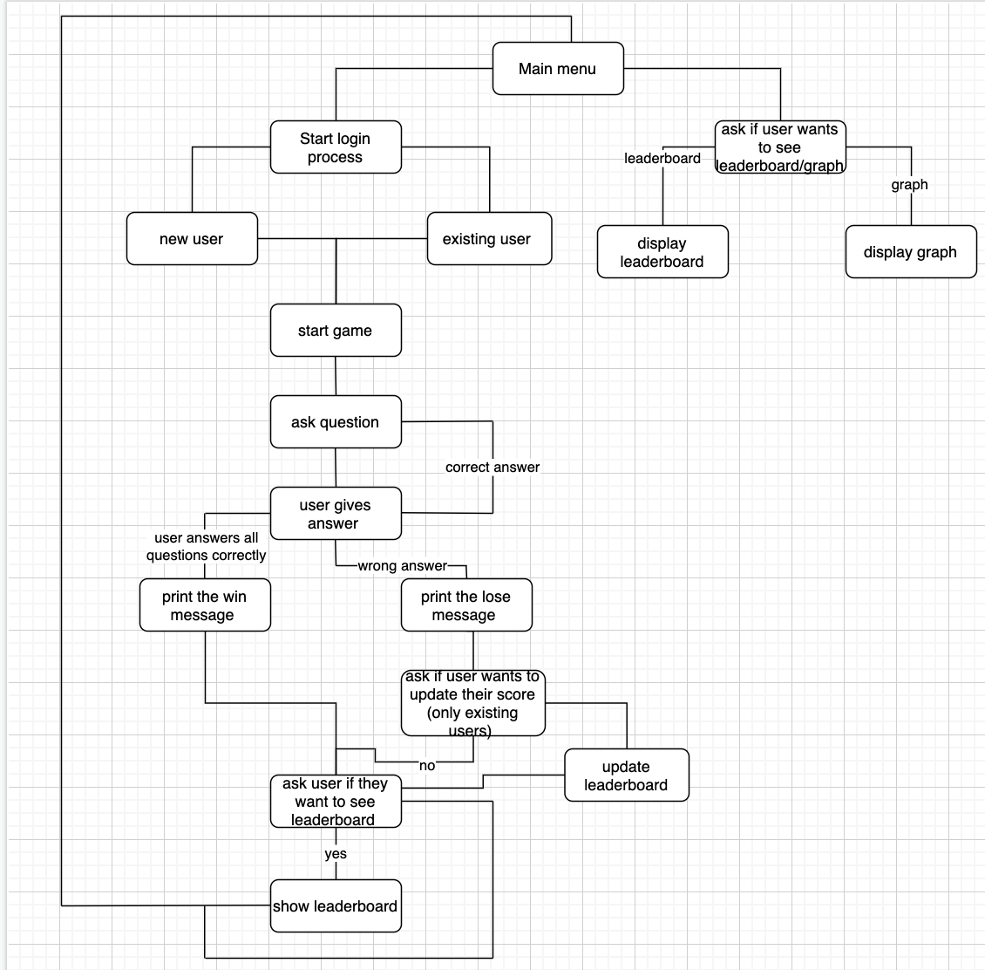

## Pseudo Code

DEFINE CLASS Login(object):

DEFINE FUNCTION encryption (self, password):

key <- Fernet.generate_key()

fernet <- Fernet(key)

encrypt <- fernet.encrypt(password.encode())

return encrypt

DEFINE FUNCTION decryption(self, password):

Key <- Fernet.generate_key()

fernet <- Fernet(key)

encrypt <- fernet.encrypt(password.encode())

return encrypt

DEFINE FUNCTION new_user(self, username, password):

run <- True

while (run is True):

sure <- INPUT(are you sure that you want your username to be that?)

If (sure is yes):

Conn <- sqlite3.connect “Everything.db”

Cur <- conn.cursor()

Cur.execute “SELECT * FROM UserPass WHERE Username <- ‘” + username +”’”

exist <- cur.fetchone()

if (exist is None):

cur.execute “INSERT INTO UserPass (Username, Password) VALUES

(‘” + username + “’, ‘” + password + “’”)

Cur.execute “COMMIT”

Cur.close()

Run <- False

Else:

Print “Unfortunately this account already exists, please choose a different Username"

M <- Menu()

M.menu()

DEFINE FUNCTION existing_user(self, username, password):

Run <- True

While (run is True):

conn <- sqlite3.connect”Everything.db”

cur <- conn.cursor()

cur.execute”SELECT * FROM UserPass WHERE Username <-

‘” + username + “’ AND Password <- ‘” + password + “’;”

Exist <- cur.fetchone()

If (exist is None):

Print “Your account does not exist”

Print “Please either re-enter your login or register a new account”

M <- Menu()

M.menu()

Else:

Print “You have logged in with username:”, username,

“and password:”, password

Run <- False

DEFINE CLASS Game(object):

DEFINE INITIALISE (self):

Self.answerl <- list : ‘A’, ‘B’, ‘C’, ‘D’, ‘Correct’

Self.answerd <- dictionary

Self.reward <- list: ‘£0’, ‘£100’, ‘£200’, ‘£300’, ‘£500’, ‘£1000’, ‘£2000’, ‘£4000’, ‘£8000’, ‘£16000’, ‘£32000’, ‘£64000’, ‘£125000’, ‘£250000’, ‘£500000’, £1000000

Self.question <- 1

Self.ask <- CALL FUNCTION Questions

Self.lst <- list

Self.lb <- CALL FUNCTION Leaderboard

Self.lifelist <- list

DEFINE FUNCTION start_game_new(self, username):

INPUT “Welcome “ + username + “ to Who Wants To Be A Millionaire! Press enter to get started”

*new_line*

Q <- 0

Lcount <- 0

Run <- true

While (run and self.question < 16):

r <- random.randint(0, 9)

self.lst <- self.ask.qs(q,r)

PRINT “Question:”, string(self.question), “for”, string(self.reward[self.question-1]))

ret0 <- self.lst[0]

ret <- “A. “ + self.lst[1]

ret +<- “B. “ + self.lst[2]

ret +<- “C. “ + self.lst[3]

ret +<- “D. “ + self.lst[4]

*new_line*

PRINT ret0

PRINT “================================”

PRINT “The possible answers are:”

*new_line*

PRINT ret1

Time.sleep(1)

PRINT ret2

Time.sleep(1)

PRINT ret3

Time.sleep(1)

PRINT ret4

self.answerd[“A”] <- self.lst[1]

self.answerd[“B”] <- self.lst[2]

self.answerd[“C”] <- self.lst[3]

self.answerd[“D”] <- self.lst[4]

self.answerd[“Correct”] <- self.lst[5]

play <- True

while (play is True):

if (lcount < 2):

life <- INPUT “Would you like to use a lifeline?”

if (life <- “yes”):

line <- INPUT “What lifeline would you like to use?”

If (line is call):

PRINT “Calling...”

*new_line*

PRINT self.lst[6]

lcount <- lcount + 1

Play <- False

Elif (line is 50/50 or 50):

Play <- False

Else:

PRINT “Please enter a valid input”

Elif (life is no):

Play <- False

Else:

PRINT “Sorry you dony have any lifelines remaining”

Play <- False

Yes <- True

While (yes is True):

User <- INPUT “Please select your answer”

User <- user.upper()

If (user in self.answerd):

pass

Else:

PRINT “please enter a valid input”

continue

Choice <- INPUT “Is that your final answer”

If (choice is yes):

yes <- False

Elif (choice is no):

continue

Else:

PRINT “Please enter a valid input”

If (user in ret1 or ret2 or ret3 or ret4):

If (self.answerd[user] = self.answerd[‘Correct’]):

If self.question = 15:

PRINT You have won a million pounds! £1000000 is yours.

PRINT That is the end of the game

conn = sqlite3.connect("Real.db")

cur = conn.cursor()

cur.execute("""SELECT Username FROM Leaderboard WHERE Username=?;""",

(username,))

chck = cur.fetchone()

if chck is None:

cur.execute("""INSERT INTO Leaderboard (Username, Score, MoneyWon) VALUES (?, ?, ?);""",

(username, self.question-1, self.reward[self.question-1]))

cur.execute("""INSERT INTO Lifelines (Username, LifelinesUsed, Score) VALUES (?, ?, ?);""",

(username, lcount, self.question))#the users scores, lifelines and moneywon are all stored in the database

cur.execute('COMMIT')

cur.close()

self.question = self.question + 1

q = q + 1

else:

cur.execute("""UPDATE Leaderboard SET Score=?, MoneyWon=? WHERE Username=?;""",

(self.question-1, self.reward[self.question-1], username))

cur.execute("""UPDATE Lifelines SET LifelinesUsed=?, Score =? WHERE Username=?;""",

(lcount, self.question-1, username))

cur.execute('COMMIT')

cur.close()

self.question = self.question + 1

q = q + 1

PRINT “The answer is”, str(self.answerd[‘Correct’])”

PRINT “You chose the right answer”

PRINT “You win”, self.reward[self.question]”

self.question <- self.question + 1

q <- q + 1

Elif (self.question is 15):

PRINT “You have won a million pounds! £1000000 is yours”

PRINT “That is the end of the game”

conn <- sqlite3.connect(Test.db)

cur <- conn.cursor()

cur.execute “””INSERT INTO Leaderboard (username, score, moenywon)

VALUES (?, ?, ?);”””,

(username, self.question, self.reward[self.question-1])

Cur.execute “””INSERT INTO Lifelines (username, score, moneywon) VALUES (?,?,?);”””, (username, lcount, self.question)

Cur.execute(COMMIT)

Cur.close()

Try:

A <- INPUT “Would you like to see your name on the leaderboard”

If ( A is ‘yes’):

self.lb.leader()

Elif (A is ‘no’):

run <- False

Except:

PRINT “Please enter a valid input”

ELIF (user in ret1 or ret2 or ret3 or ret4):

If (self.answerd[user] !<- self.answerd[‘Correct’]):

PRINT “The answer is, “, self.answerd[‘Correct’]

PRINT “Unfortunately you chose the wrong answer”

PRINT “That means you walk away with, “, self.reward[self.question-1]

conn <- sqlite3.connect(Test.db)

cur <- conn.cursor()

check <- cur.execute “””SELECT Username FROM Leaderboard WHERE Username<-?;”””, (username,)

if (check is None):

cur.execute “””INSERT INTO Leaderboard (username, score, moneywon) VALUES (?,?,?);”””,

(username, self.question, self.reward[self.question-1])

Cur.execute “”” INSERT INTO Lifelines (username, lifelinesused, score) VALUES (?,?,?);”””,

(username, lcount, self.question)

Cur.execute(COMMIT)

Cur.close()

Else:

Qus <- INPUT “Would you like to update your previous score”

If (qus is “yes”):

Cur.execute “””UPDATE Leaderboard SET score<-?, MoneyWon<-? WHERE Username<-?;””",

(self.question, self.reward[self.question-1], username)

Cur.execute “””UPDATE Lifelines SET LifelinesUsed<-?, Score<-? WHERE Username<-?;”””,

(lcount, self.question, username)

Cur.execute (COMMIT)

Cur.close()

Elif (qus is ‘no’):

Pass

Else:

Print “Please enter a valid input”

Run <- False

Play <- False

Self.question <- 16

B <- INPUT “Would you like to see your name on the leaderboard”

If (b is ‘yes’):

Self.lb.leader()

Elif (b is ‘no’):

Run <- False

Else:

Run <- False

Else:

PRINT “Please enter a valid input”

Continue

M <- Menu()  
m.menu()

DEFINE FUNCTION fifty_fifty(self):

while count <<- 2:

d <- random.randint(1,4)

if self.answerd[d] = self.answerd[Correct]:

pass

else:

Self.asnwersd.remove(d)

count <- count + 1

print()

if self.answerd['A'] is None:

pass

else:

print self.answerd['A']

if self.answerd['B'] is None:

pass

else:

print self.answerd['B']

if self.answerd['C'] is None:

pass

else:

print self.answerd['C']

if self.answerd['D'] is None:

pass

else:

print self.answerd['D']

if self.answerd['Correct'] is None:

pass

else:

print self.answerd['Correct']

print(ret)

CLASS Leaderboard:

DEFINE INITIALISE (self):

Self.data <- LIST

Self.height <- LIST

Self.leaderboard <- DICTIONARY “Name”:[], “Score”:[], “Prize”:[]

Self.leaderboard2 <- DICTIONARY “Name”:[], “Score”:[], “Prize”:[]

FUNCTION leader(self):

Conn <- sqlite3.connect(Test.db)

Cur <- conn.cursor()

Cur.execute SELECT Username,Score,MoneyWon FROM Leaderboard ORDER BY Score DESC

Tup <- cur.fetchall()

If (tup is None):

PRINT “There are no results yet, play the game and be the first on the leaderboard”

Else:

F <- 0

For i in tup:

For k in i:

Self.data.append(k)

f <- 0

t <- 0

While t < len(self.data):

Self.leaderboard[“Name”].append(self.data[f])

f <- f + 1

t <- t + 1

self.leaderboard[“Score”].append(self.data[f])

f <- f + 1

t <- t + 1

self.leaderboard[“Prize”].append(self.data[f])

f <- f + 1

t <- t + 1

table <- pd.DataFrame(self.leaderboard)

*new_line*

PRINT table

FUNCTION lifes_used(self):

conn <- sqlite3.connect(Test.db)

cur <- conn.cursor()

cur.execute “SELECT Username, LifelinesUsed, Score FROM Lifelines ORDER BY LifelinesUsed ASC”

tup <- cur.fetchall()

if (tup is None):

PRINT “There are no results yet, play the game and be the first on the leaderboard”

Else:

Pass

For i in tup:

For u in i:

Self.data.append(u)

F <- 0

T <- 0

While t < len(self.data):

Self.leaderboard2[“Name”].append(self.data[f])

f <- f + 1

t <- t + 1

self.leaderboard2[“LifelinesUsed”].append(self.data[f])

f <- f + 1

t <- t + 1

self.leaderboard2[“Score”].append(self.data[f])

f <- f + 1

t <- t + 1

table <- pd.DataFrame(self.leaderboard2)

*new_line*

PRINT table

DEFINE FUNCTION Graph(self):

Left <- [1,2]

Height <- []

Conn <- sqlite3.connect(Test.db)

Cur <- conn.cursor

cur.execute “SELECT avg(Score) FROM Leaderboard”

tup <- cur.fetchone()

for i in tup:

height.append(i)

tee <- INPUT “Please enter your username to compare your score to the average”

conn <- sqlite3.connect(“Test.db”)

cur <- conn.cursor()

hee <- cur.execute “SELECT Score FROM Leaderboard WHERE Username <- tee”

ha <- hee.fetchone()

if (ha <- none):

PRINT “Your account was not found, please enter a valid username”

else:

height.append(ha)

tick_label <- [Average Score, Your Score]

plt.bar(left, height, tick_label <- tick_label,

width <- 0.7, colour <- [green, blue]

plt.xlabel(Score)

plt.ylabel(User)

plt.title(Graph to show the average vs the user)

plt.show()

plt.close()

CLASS Menu:

DEFINE Initialise(self):

self.game <- Game()

self.login <- Login()

self.leaderboard <- Leaderboard()

DEFINE FUNCTION menu (self):

let <- True

while let:

choice <- INTEGER INPUT “1. Start Game, 2. Check Leaderboard, 3. Quit”

if (choice <- 1):  
 f <- INPUT “Are you a new or existing user (n or e)”

if (f <- new OR n):

PRINT “Welcome, to continue onto the game please register an account or

login to an existing one”

PRINT “This is done so your score can be tracked in a leaderboard”

run <- True

while run:

username <- INPUT “What would you like your username to be?”

password <- INPUT “What would you like your password to be?”

show <- INPUT “Would you like to see your username and

password?”

if (show <- yes):

PRINT “Your username is:”, username

PRINT “Your password is:”, password

elif (show <- no):

run <- False

else:

continue

self.login.new_user(username, password)

self.game.start_game_new(username)

elif (f <- existing or e):

run <- True

while run:

PRINT “Welcome back! Please login to continue”

mu <- INPUT “Press m if you would like to return to the main menu, otherwise press any button”

if (mu <- m):

Menu.menu(self)

else:

username <- INPUT “Please enter your username”

password <- INPUT “Please enter your password”

self.login.existing_user(username, password)

self.game.start_game_new(username)

run <- False

elif (choice <- 2):

sel <- INTEGER INPUT “1.Overall leaderboard, 2.Lifeline counter, 3. Average Score”

if (sel <- 1):

self.leaderboard.leader()

elif (sel <- 2):

self.leaderboard.lifes_used()

elif (sel <- 3):

self.leaderboard.graph()

else:

PRINT “Please choose a valid option”

Elif (choice is 3):

quit()

Else:

PRINT “Please choose a valid input@

CLASS Questions ():

DEFINE FUNCTION qs (self, q, r):

RETURN a[q][r]

A <- [[0 for u in range(10)] for u in range(15)]

a[0][0] <- ["In the UK, the abbreviation NHS stands for National what Service?","Humanity","Health","Honour","Household","Health", "I'm quite sure its health..."]

a[0][1] <- ["A spork is a utensil that typically combines a fork with which other item?", "Colander", "Whisk", "Spoon", "Corkscrew", "Spoon", "How did you not get that one, of course its a spoon"]

a[0][2] <- ["Obtaining the full details on something is said to be 'getting the' what?", "Lowdown", "Highdown", "Showdown", "Throwdown", "Lowdown", "It is 100% the lowdown, im surpirsed you didnt know that"]

a[0][3] <- ["According to legend, what was the name of the wizard who was adviser to King Arthur?", "Mervin", "Martin", "Marcus", "Merlin", "Merlin", "Dont ask how I know but it im pretty sure is Merlin"]

a[0][4] <- ["Which of these is most likely to be used as an archer?", "Bitterbow", "Crossbow", "Furiousbow", "Iratebow", "Crossbow", "Definantly a crossbow, what else?"]

a[0][5] <- ["On 24th March 2018, Clare Balding fronted live television coverage of which annual race?", "The Boat Race", "The Sack Race", "The Egg and Spoon Race", "The Three-Legged Race", "The Boat Race", "That's an easy one, its the boat race"]

a[0][6] <- ["Violing, violas and cellos all belong to what section of an orchestra?", "Yarn", "Twine", "String", "Rope", "String", "The answer is definantly string, I have no doubt"]

a[0][7] <- ["To apprehend someone in the act of committing a crime is to 'catch them...' what?", "Red-eyed", "Red-handed", "Red-headed", "Red-nosed", "Red-handed", "I've heard of this term before its 100% 'red-handed'"]

a[0][8] <- ["Which of these is the name of a traditional guessing game, often played on car journeys?", "I tinker", "I tailor", "I soldier", "I spy", "I spy", "You never played it before? Its 'I spy'"]

a[0][9] <- ["Which of these is a kind of porcelain?", "Marvellous mongolia", "Interesting india", "Priceless pakistan", "Fine china", "Fine china", "The answer is 100% Fine china im confident"]

a[1][0] <- ["Which Disney character famously leaves a glass slipper behind at a royal ball?","Pocahontas","Sleeping Beauty","Cinderella","Elsa","Cinderella", "Let me think, its Cinderella if I remember correctly"]

a[1][1] <- ["Someone expressing their anger is said to be 'venting their...' what?", "Spleen", "Liver", "Intestines", "Pancreas", "Spleen", "Someone said it at work today, its definantly A"]

a[1][2] <- ["A fascinator is usually worn on which part of the body?", "Head", "Shulders", "Knees", "Toes", "Head", "I saw them at Ascot when i went there, my final answer is head"]

a[1][3] <- ["What name is given to a dessert made with strawberries, meringue and whipped cream?", "Harrow muck", "Eton Mess", "Gordonstoun trifle", "Winchester shambles", "Eton Mess", "How ironic...I am having one right now, Eton Mess final answer"]

a[1][4] <- ["Who was appointed as the chief architect and supervisor of the rebuilding of St Paul's Cathedral after the Great Fire of London?", "Christpoher Robin", "Christopher Starling", "Christopher Wren", "Christopher Bullfinch", "Christopher Wren", "I know Chrisopher Wren is a famous architect so my final answer is C"]

a[1][5] <- ["Residents of cornwall and Devon traditionally disagree about the order in which cream and jam are placed on what food item?", "Scone", "Crumpet", "Pasty", "Kebab", "Scone", "Surprised you needed help with that...its definantly scone"]

a[1][6] <- ["Which of these is the name of the conspirator in the 1605 Gunpowder Plot?", "Guy Skewers", "Guy Nives", "Guy Fawkes", "Guy Spoones", "Guy Fawkes", "Do you know any history of bonfire night? Its Guy Fawkes"]

a[1][7] <- ["Whis of these animals is 'duck-billed'?", "Kangaroo", "Wallaby", "Platypus", "Koala", "Platypus", "Has to be a platypus since thats the one that lives in water"]

a[1][8] <- ["Which of these is the name of a sport included in the 2016 Summer Olympics programme?", "Integrated swimming", "Synchronised swimming", "Coordinated swimming", "Same-time swimming", "Synchronised swimming", "I watched it last time, its synchronised swimming"]

a[1][9] <- ["What was the first name of the character played by John Cleese in 'Fawlty Towers'?", "Chives", "Dill", "Mint", "Basil", "Basil", "You ever watched that series? Its Basil"]

a[2][0] <- ["What name is given to the revolving belt machinery in an airport that delivers checked luggage from the plane to baggage reclaim?", "Hangar", "Terminal", "Concourse", "Carousel", "Carousel", "Its definantly not hangar or termianl...I think its carousel i'm 70% sure"]

a[2][1] <- ["Which of this is a breed of spaniel?", "King James", "King John", "King Charles", "King George", "King Charles", "Good that you called me because I have one, King Charles final answer"]

a[2][2] <- ["Meghan Markle starred in which of these TV Series?", "Big Little Lies", "Suits", "The Crown", "Orange Is the New Black", "Suits", "I remember watching it and seeing her, the answer is definantly suits"]

a[2][3] <- ["Little, tawny and snowy are species of which bird", "Sparrow", "Cuckoo", "Owl", "Parrot", "Owl", "I am pretty sure its owl, final answer"]

a[2][4] <- ["According to Robert Burns, which food is the 'Great chieftain o' the pudding-race'?", "Teacake", "Haggis", "Bacon Roll", "Sticky toffee pudding", "Haggis", "Dont ask how I know this but it is Haggis, final answer"]

a[2][5] <- ["'Chippy' is a common slang term for which tradesperson?", "Electrician", "Gardener", "Carpenter", "Bricklayer", "Carpenter", "I'm pretty sure is carpenter, but im not certain"]

a[2][6] <- ["In the 1950 C.S. Lewis novel, Peter, Susan, Edmund and Lucy enter Narnia through which household item?", "Wardrobe", "Mirror", "Refrigerator", "Bath tub", "Wardrobe", "Mirror has thrown me off a bit but Im confident its wardrobe"]

a[2][7] <- ["Which of these is a horse race run annually at Epsom Downs?", "The Bolton", "The Loughborough", "The Sunderland", "The Derby", "The Derby", "I think its the derby, im pretty sure"]

a[2][8] <- ["Which of these countries did not host a Formula 1 Grand Prix race in 2003?","Monaco","France","Italy","Madagascar","Madagascar", "Don't remember Madagascar ever having a race so thats my answer"]

a[2][9] <- ["In 2012, the British athlete Greg Rutherford won an Olympic gold medal in which event?", "Long jump", "Pole vault", "Hammer throw", "Shot put", "Long jump", "I think i remember seeing him do long jump, thats my answer"]

a[3][0] <- ["Which of these brands was chiefly associated with the manufacture of household locks?", "Philips", "Flymo", "Chubb", "Ronseal", "Chubb", "I just know Phillips do screwdrivers so its definantly not them...my guess is Chubb"]

a[3][1] <- ["Which of these is the title of a famous artwork by Tracey Emin?", "Our Settee", "Your Bench", "Her Desk", "My Bed", "My Bed", "I think its My Bed but im not entierely sure"]

a[3][2] <- ["'Trebles for show, doubles for dough' is a phrase usually assosciated with which sport?", "Croquet", "Basketball", "Curling", "Darts", "Darts", "I am a big darts fan and I remember the phrase being said, darts final answer"]

a[3][3] <- ["The national flag of Sweden consists of which two colours?", "Blue and white", "White and Red", "Red and Yellow", "Yellow and Blue", "Yellow and Blue", "Well..IKEA is Blue and Yellow so I will say D, final answer"]

a[3][4] <- ["Something that gives away the plot or outcome of a TV show is called a... what?", "Fender", "Splitter", "Muffler", "Spoiler", "Spoiler", "It is obviously spoiler...I think you're nervous"]

a[3][5] <- ["What is the title of the 1965 Bond film starring Sean Connery?", "Thunderball", "Fireball", "Screwball", "Cannonball", "Thunderball", "This is a classic, of course its Thunderball"]

a[3][6] <- ["The famous landmark The Blackpool Tower is in which English county?", "Lancashire", "Hertfordshire", "Somerset", "Kent", "Lancashire", "Surprised you stumbled on this one, its Lancashire"]

a[3][7] <- ["Which of these is a unit of spped equivalent to nautical mile per hour?", "Ribbon", "Tie", "Knot", "Bow", "Knot", "Im sure its knot, never heard any of the other ones describe speed"]

a[3][8] <- ["In the 'Super Mario Bros' game franchise, what is the name of Mario's brother?", "Leonardo", "Lorenzo", "Luigi", "Larry", "Luigi", "Im surprised you needed help with this one but its Luigi"]

a[3][9] <- ["Which of these is a term for a group of actors or musicians who perform together?", "Ensuite", "Envogue", "Ensemble", "Engarde", "Ensemble", "I like to think its ensemble, but im not 100% confident"]

a[4][0] <- ["The hammer and sickle is one of the most recognisable symbols of which political ideology?", "Republicanism", "Communism", "Convervatism", "Liberalism", "Communism", "I did this in university its definantly communism"]

a[4][1] <- ["What is the name of the character played by Daisy Ridley in 'Star Wars: The Last Jedi'?", "Doh", "Rey", "Mee", "Farr", "Rey", "I have watched it and it is definantly Rey"]

a[4][2] <- ["Which of these is credited with inventing a type of compression-ignition engine?", "Franz Ethanol", "Dieter Propane", "Rudolf Diesel", "Hans Unleaded", "Rudolf Diesel", "Well all I know is that there is a diesel engine and all of these other names dont sound like engines, C final answer"]

a[4][3] <- ["Which of these is a term meaning 'collective intelligence'?", "Hutch mind", "Warren mind", "Sett mind", "Hive mind", "Hive mind", "Im pretty sure its Hive Mind if I remember correctly"]

a[4][4] <- ["LHR is the three-letter code for which UK airport?", "Liverpool", "Leicester", "Heathrow", "Humbershire", "Heathrow", "Dont you remember flying on holiday from there? Heathrow, final answer"]

a[4][5] <- ["In the folk tale 'Ali Baba and the Forty Thieves', what command does Ali Baba give to access a cave full of treasure?", "Abracadabra!", "Hocus, Pocus!", "Shazaam!", "Open, Sesame!", "Open, Sesame!", "If I remember correctly it is D, final answer"]

a[4][6] <- ["Which of these characters is voiced by James Corden in a 2018 film?", "Roger Rabbit", "Bugs Bunny", "Peter Rabbit", "Thumper", "Peter Rabbit", "I remember this movie coming out..I believe its Peter Rabbit, im not certain though"]

a[4][7] <- ["What is the name of the character played by Kit Harington in the TV drama 'Game of Thrones'?", "Edward Showers", "Jacob Sleet", "Jon Snow", "Barry Rain", "Jon Snow", "I've personally never watched it so I have no clue, possibly Barry Rain"]

a[4][8] <- ["Which of these is not one of the three body segments of an adult insect?", "Head", "Thorax", "Abdomen", "Appendix", "Appendix", "Im pretty sure its appendix, I am confident"]

a[4][9] <- ["Which of these might be sprinkled on a rice pudding?","Cinnabar","Cinnamon","Cincinnati","Cinerama","Cinnamon", "I had it this morning, its cinnamon"]

a[5][0] <- ["Which toys have been marketed with the phrase “robots in disguise”?", "Bratz Dolls", "Sylvanian Families", "Hatchminals", "Transformers", "Transformers", "The only one I know that aren't real people are Transformers, so go with that"]

a[5][1] <- ["Which county club play their home matches at the Oval?", "Middlesex", "Surrey", "Essex", "Hampshire", "Surrey", "I dont watch cricket but I know where the oval is...I think its Surrey"]

a[5][2] <- ["In the classic Hitchcock film 'Psycho', the famous shower scene takes place in which fictioal motel?", "Crane Motel", "Bates Motel", "Jefferies Motel", "Novak Motel", "Bates Motel", "The main character in the film was Bates so, Bates Motel final answer"]

a[5][3] <- ["In Greek mythology, who is the Goddess of Victory?", "Umbro", "Reebok", "Adidas", "Nike", "Nike", "None of these really sound like Greek words, I guess i'll go with Umbro"]

a[5][4] <- ["In the 'Transformers' film franchise, who is the leader of the Deceptions?", "Megaphone", "Megabyte", "Megatron", "Megabus", "Megatron", "You ever watched Transformers? Clearly not, Megatron final answer"]

a[5][5] <- ["In September 2017, the Bank of England issued a new £10 note featuring which author?", "Charlotte Bronte", "J.K Rowling", "Virginia Woolf", "Jane Austen", "Jane Austen", "Let me think...I think its Jane Austen if I remember correctly, im 70% sure"]

a[5][6] <- ["The hindu god Ganesh is traditioanally depicted as having the head of which animal?", "Elephant", "Tiger", "Rhino", "Cobra", "Elephant", "Its definantly elephant im very sure of it"]

a[5][7] <- ["Which meat is traditionally the main ingredient in the French dish 'coq au vin'?", "Chicken", "Beef", "Lamb", "Venison", "Chicken", "I think I had that when I went to France, I remember it having chicken"]

a[5][8] <- ["What is the title of the first chapter of the book 'Harry Potter and the Philosopher's Stone'?", "The Missing Mirror", "The Prince's Tale", "The Seven Potters", "The Boy Who Lived", "The Boy Who Lived", "I love Harry Potter, my answer is The boy who lived"]

a[5][9] <- ["Which of these is the main ingredient in a basic Indian 'dhal'?", "Lentils", "Potatoes", "Spinach", "Cauliflower", "Lentils", "Always one of my favourites, the answer is lentils"]

a[6][0] <- ["What does the word loquacious mean?", "Angry", "Chatty", "Beautiful", "Shy", "Chatty", "Sounds like something you would say about a sunset, so i'd say it means beautiful...not sure though never heard of the word"]

a[6][1] <- ["For what reason did Proffesor Robert Kelly gain internet fame in 2017?", "Mistaken identity on news", "Chasing after his dogs", "Kids gatecrashed interview", "Trying to catch a bat", "Kids gatecrashed interview", "I think I remember seeing this on the news so I think the answer is C"]

a[6][2] <- ["Vitamin B9 is also known by which of these names?", "Riboflavin", "Folic Acid", "Biotin", "Thiamin", "Folic Acid", "Its a complete guess but I think its Riboflavin, im honestly not sure"]

a[6][3] <- ["Which is not an electrical SI unit of measurement?","Volt","Ampere","Ohm","Gallon","Gallon"]

a[6][4] <- ["In 2000, which country joined rugby union's Five Nations Championship to make it the Six Nations?", "Romania", "Georgia", "Italy", "Spain", "Italy", "It is definanlty Italy, I still remember when they werent part of it"]

a[6][5] <- ["Wagyu is a Japanese breed of which animal?", "Cow", "Sheep", "Pig", "Chicken", "Cow", "You ever heard of a wagyu steak? It cow 100%"]

a[6][6] <- ["At the start of a game of chess, what is the total number of pawns on the board?", "Twelve", "Fourteen", "Sixteen", "Eighteen", "Sixteen", "I played chess the other day so im quite sure its sixteen"]

a[6][7] <- ["The historic location known as Checkpoint Charlie is a tourist attraction in which city?", "Warsaw", "Berlin", "Prague", "Vienna", "Berlin", "I remember learning about this in school, its Berlin"]

a[6][8] <- ["Who is the Roman Catholic patron saint of hopeless causes?", "St Jude", "St Julian", "St Jerome", "St Jeremy", "St Jude", "I have no clue at all, im going to guess St Jeremy"]

a[6][9] <- ["In March 2018, it was reported that Mount Etna is slowly sliding towards which neighbouring sea?", "Red", "Black", "Mediterranean", "Baltic", "Mediterranean", "Mount Etna is near sicily so that would be the mediterranean"]

a[7][0] <- ["Obstetrics is a branch of medicine particularly concerned with what?" , "Childbirth", "Broken Bones", "Heart Conditions", "Old Age", "Childbirth", "I've heard about this before, its Childbirth"]

a[7][1] <- ["Which of these words can be typed on a single row of a standard UK 'QWERTY' keyboard?", "Cheese", "Pork", "Salad", "Lager", "Salad", "I think its between pork and salad...I cant remember a keyboard fully"]

a[7][2] <- ["Which is a tough durable synthetic material?","PVC","PTO","POW","PBX","PVC", "I believe its PVC but im not entirely sure"]

a[7][3] <- ["Which is a breed of dog formerly used as coach dogs?","Croatian","Dalmatian","Montenegran","Bosnian","Dalmatian", "I honestly have no clue, I would just be guessing...croatian"]

a[7][4] <- ["What type of creature is a bunting?", "Bird", "Fish", "Frog", "Lizard", "Bird", "I know all about this, it is certainly bird final answer"]

a[7][5] <- ["What does the letter 'U' stand for in the name of the global children's agency UNICEF?", "United", "Uniform", "Unison", "Universal", "United", "Im honestly not sure, I think its united but I have doubts"]

a[7][6] <- ["In Scotland, what name designates any mountain peak 3,00 feet and over?", "Hamilton", "Munro", "Paisley", "Peebles", "Munro", "I am lost on this question, I think it may be Paisley"]

a[7][7] <- ["In 2012, Jean Dujardin won an Oscar for his role as a silent movie actor in which film?", "The Machinst", "The Postman", "The Artist", "The Pianist", "The Artist", "Its between the artist and the pianist, im just not sure which one its honestly 50/50, im going with the artist"]

a[7][8] <- ["What would you normally do with a Liebfraumilch?","Drink it","Play a tune on it","Drive it","Sit on it","Drink it", "Im sorry but I dont know, my guess is drink it"]

a[7][9] <- ["Which clothing item is named after a 19th century trapeze artist?", "Culottes", "Bikini", "Leotard", "Camisole", "Leotard", "I believe its leotard, but im just not 100% sure"]

a[8][0] <- ["In Doctor Who, what was the signature look of the fourth Doctor, as portrayed by Tom Baker?", "Bow-tie, braces and tweed jacket", "Wide-brimmed hat and extra long scarf", "Pinstripe suit and trainers", "Cape, velvet jacket and frilly shirt", "Wide-brimmed hat and extra long scarf", "Oh that was my favuorite Doctor Who...the answer is B"]

a[8][1] <- ["Which term means a dry wind blowing from North Africa, that picks up moisture crossing the Mediterrenan", "Mistral", "Sargasso", "Pampero", "Sirocco", "Sirocco", "I think its the Sargasso but honestly I do not know any of these, it is a complete guess"]

a[8][2] <- ["Which of these words is used to identify an Internet server?","Realm","Province","Kingdom","Domain","Domain"]

a[8][3] <- ["Which is an alternative name for a peanut?","Earthnut","Soilnut","Groundnut","Allnut","Groundnut"]

a[8][4] <- ["in Hokusai's print 'The Great Wave', which mountain is depcited in the background?", "Mount Emei", "Mount Kailash", "Mount Fuji", "Mount Sinai", "Mount Fuji", "The only Japanese mountain I know is Fuji, so I guess just go with that"]

a[8][5] <- ["'Cilantro' is the Spanish word for which herb?", "Basil", "Sage", "Coriander", "Rosemary", "Coriander", "Well the only other one that begins with c is coriander so im going with that, C final answer"]

a[8][6] <- ["Auguste Escoffier is most assosciated with which field?", "Painting", "Photography", "Cookery", "Music", "Cookery", "That is a tough one, I think its cookery but I wouldn't be surprised if it was painting"]

a[8][7] <- ["In Rene Magritte's portrait 'The Son of Man', the subject wears what type of hat?", "Bobble", "Beret", "Bowler", "Boater", "Bowler", "I have no clue about art to be honest, it sounds French so beret maybe"]

a[8][8] <- ["Originating in Italy, what type of food is mortadella?","Sausage","Pasta","Cheese","Pastry","Sausage"]

a[8][9] <- ["Which of these is the title of a 1985 dystopian novel by Margaret Atwood?", "The Butler's Story", "The Servant's Account", "The Handmaid's Tale", "The Nanny's Report", "The Handmaid's Tale", "I read the book and saw they made a tv show about it recently, the answer is C"]

a[9][0] <- ["Which of these religious observances lasts for the shortest period of time during the calendar year?", "Ramadan", "Diwali", "Lent", "Hanukkah", "Diwali", "I'm confident is is Diwali, go with B"]

a[9][1] <- ["What is the French word for England?","Angleterre","Etats-Unis","Inglaterra","Bretagne","Angleterre", "I've never heard of these words before, maybe its angleterrer"]

a[9][2] <- ["Which of these describes the rich and famous?","Glitterati","Hoi polloi","Establishment","Paparazzi","Glitterati", "The word glitterati sounds familiar, thats my answer"]

a[9][3] <- ["Which Italian term is used to describe painting on wet plaster?","Frappe","Fresco","Fredo","Frisson","Fresco"]

a[9][4] <- ["According to the Highway Code, what shape is the standard sign giving the order to 'Stop'?", "Pentagon", "Hexagon", "Heptagon", "Octagon", "Octagon", "It could be a hexagon or octagon, I honestly cant remember to be honest with you"]

a[9][5] <- ["The jazz musician Dave Brubeck was best known for playing which instrument?", "Piano", "Double Bass", "Trumpet", "Drums", "Piano", "I honestly have no clue, im going to say piano"]

a[9][6] <- ["'The Dead of Jericho' was the title of the first broadcast episode of which TV crime drama series?", "Midsomer Murders", "Inspector Morse", "Cracker", "A Touch of Frost", "Inspector Morse", "A complete guess as I dont watch these at all, I reckon Inspector Morse"]

a[9][7] <- ["What colour light indicates the port side of a ship?","Yellow","White","Blue","Red","Red", "I work with ships so I know its red"]

a[9][8] <- ["Which US city is the setting for the TV sitcom 'Taxi'?","Boston","Dallas","Los Angeles","New York","New York", "When I think tax I think New York so thats my answer"]

a[9][9] <- ["Which siogan featured on a 1943 poster of a woman in a red and white headscarf flexing her arm muscle?", "I Want You!", "Dig for Victory", "We Can Do It!", "Keep Calm and Carry On", "We Can Do It!", "They all sound like they can be right, I think im going to go with 'We Can Do It!'"]

a[10][0] <- ["At the closest point, which island group is only 50 miles south-east of the coast of Florida?", "Bahamas", "US Virgin Islands", "Turks and Caicos Islands", "Bermuda", "Bahamas", "I think its the Bahamas...I went on a trip there last year when I was in Florida"]

a[10][1] <- ["According to the Bible, which of these is not an archangel?","Michael","Raphael","Gabriel","Ishmael","Ishmael", "My bible knowledge is not the best but I dont remember there being an Ishamel"]

a[10][2] <- ["Which of these titles was bestowed upon Margaret Thatcher?","Marchioness","Duchess","Baroness","Countess","Baroness", "It definantly is Baroness, im quite sure"]

a[10][3] <- ["Which Jimmy, born in Jamaica in 1948, became a reggae star?","Edge","Mount","Cliff","Tor","Cliff", "I think it may be Cliff im not certain though"]

a[10][4] <- ["In the Bible, which land is said to be 'east of Eden'?", "Nineveh", "Nod", "Nazareth", "Nimrud", "Nod", "I have no clue sorry...Im going to say Nazareth"]

a[10][5] <- ["What did the legendary Trojan horse contain?","Horses","Gold","Wheat","Soldiers","Soldiers", "Im pretty sure it contained soldiers but im really not sure sorry"]

a[10][6] <- ["Margaret Thatcher's university tutor Dorothy Hodgkin won a Nobel Prize in which field?", "Physics", "Chemistry", "Economic Sciences", "Peace", "Chemistry", "I've never heard of Dorothy Hodgkin before..my guess is that its Economic sciences"]

a[10][7] <- ["Which present-day eastern European country was not part of the former USSR?","Hungary","Lithuania","Ukraine","Latvia",""]

a[10][8] <- ["The Mount of Olives is just east of which city?","Jerusalem","Moscow","Hong Kong","Paris","Jerusalem"]

a[10][9] <- ["In 2016, whom did Boris Johnson succeed as Foreign Secretary?", "Liam Fox", "Phillip Hammond", "Kenneth Clarke", "William Hague", "Phillip Hammond", "I honestly dont know, I think it may be Phillip Hammond but I honestly dont know"]

a[11][0] <- ["Construction of which of these famous landmarks was completed first?", "Empire State Building", "Royal Albert Hall", "Eiffel Tower", "Big Ben", "Big Ben", "I'm 50/50 on this one...it's either Big Ben or Royal Albert Hall, sorry"]

a[11][1] <- ["Which dinosaur could fly?","Allosaurus","Diplodocus","Stegosaurus","Pterodactyl","Pterodactyl", "If I remember correctly it is a Pterodactyl, I hope thats right"]

a[11][2] <- ["Which president was elected unopposed to a sixth term in March 2003?","George W Bush","Fidel Castro","Mary McAleese","Vladimir Putin","Fidel Castro", "Im rubbish with political history, but I will guess its George Bush"]

a[11][3] <- ["What, in August 2003, was 'Sobig.F'?","New airline","Computer virus","Archaeological dig","Meteorite","Computer virus", "I believe it was a computer virus but it could also be a meteorite"]

a[11][4] <- ["In October 2003, which became the third nation to put a man into space?","Japan","South Africa","Australia","China","China", "I think its China, they are the biggest power out of those 3"]

a[11][5] <- ["What would you normally do with a mai tai?","Eat it","Wear it","Drink it","Sing it","Drink it", "I believe you drink it but I may be wrong"]

a[11][6] <- ["What was the name of the two NASA missions sent to Mars in 1975?","Viking","Visigoth","Saxon","Hun","Viking", "I dont really know this one but Viking sounds like something the would call it"]

a[11][7] <- ["Which of these is an international motoring insurance?","Yellow card","Green card","Blue card","Red card","Green card", "Its green card, not sure how I know that but thats my final answer"]

a[11][8] <- ["What shape is an Australian Rules football pitch?","Rectangular","Circular","Diamond","Oval","Oval", "I remember watching it one time and found it a bit weird, its oval"]

a[11][9] <- ["Which is not one of golf's 'Majors'?","USPGA","US Masters","US Open","US Pro-Am","US Pro-Am", "I do watch golf and I dont remember seeing the US Pro-Am so thats my answer"]

a[12][0] <- ["Which of these cetaceans is classified as a “toothed whale”?", "Gray Whale", "Minke Whale", "Sperm Whale", "Humpback Whale", "Sperm Whale", "I'm not 100% sure but I believe its the Sperm Whale, that's my final answer"]

a[12][1] <- ["David Gates was the lead vocalist with which US band?","Yeast","Money","Dough","Bread","Bread", "My knowledge in this is terrible I honestly have no clue, who names a band bread anyways"]

a[12][2] <- ["Which of these is not a grain crop?","Wheat","Millet","Maize","Soya","Soya", "I know a bit about farming and im pretty sure the answer is soya"]

a[12][3] <- ["On a standard computer keyboard, what letter lies between 's' and 'f'?","c","d","e","r","d", "This is so easy I cant believe im struggling with this, I think its e"]

a[12][4] <- ["What type of fashion accessory is a 'pillbox'?","Scarf","Hat","Belt","Skirt","Hat", "This must be a ver old term because I've never heard of it..it might be hat"]

a[12][5] <- ["In which year was the last successful invasion of Britain?","55 BC","1066","1812","1914","1066", "I remember learning something about this in history when I was younger..I think its 1066"]

a[12][6] <- ["What name is given to the German air force?","Blitzkrieg","Luftwaffe","Panzer","Messerschmidt","Luftwaffe", "Im certain its the Luftwaffe, although Blitzkreig has crossed my mind"]

a[12][7] <- ["If you arrived at Split airport, which country would you be in?","Slovakia","Slovenia","Croatia","Hungary","Croatia", "I beleive when I travelled to Croatia I landed here so my answer is Croatia"]

a[12][8] <- ["Which of these oceans is the smallest?","Arctic","Pacific","Atlantic","Indian","Arctic", "Its either the Indian or Arctic, im not certain which one it is"]

a[12][9] <- ["The Dolomites are a range of mountains in the northeast of which country?","Poland","Turkey","Germany","Italy","Italy", "I know the alps are in Italy but im not sure if it has anything to do with it, im going with Italy"]

a[13][0] <- ["Who is the only British politician to have held all four 'Great Offices of State' at some point durin their career?", "David Lloyd George", "James Callaghan", "Harold Wilson", "John Major", "James Callaghan", "I'm rubbish at politics...I think its A but I honestly do not know"]

a[13][1] <- ["Which of these deserts is in the USA?","Atacama Desert","Gobi Desert","Sahara Desert","Mojave Desert","Mojave Desert", "I know for a fact its not the Sahara but thats all the help I can give really"]

a[13][2] <- ["In which US state is the city of Tucson?","Arizona","Kansas","Texas","Colorado","Arizona", "I went there on a trip once and I believe its Arizona"]

a[13][3] <- ["Approximately 61% of the world's population live on which continent?","Northh America","Europe","Asia","Africa","Asia", "Asia is the biggest out of all of them I think so Im saying Asia"]

a[13][4] <- ["What is the English title of the Brazilian film 'Cidade de Deus'?","Church","City of God","Angels","Eternal City","City of God", "I dont know the brazilian language at all but deus possibly means god, its a complete guess"]

a[13][5] <- ["What nationality is the tennis player Alex Corretja?","Peruvian","Chilean","Brazilian","Spanish","Spanish", "I dont know much about tennis, however this does sound like a Spanish name"]

a[13][6] <- ["Which sport is played by the Edmonton Oilers?","Basketball","Baseball","American football","Ice hockey","Ice hockey", "This is my favourite hockey team, the answer is hockey"]

a[13][7] <- ["Which sport uses the Christmas Tree starting system?","Formula 1","Motocross","Drag racing","Car rallying","Drag racing", "I dont really know what this means to be honest, I know its not F1 though"]

a[13][8] <- ["Which Formula 1 racing team has won the most Constructor's titles?","Williams","Ferrari","Lotus","McLaren","Ferrari", "It has to be Ferrari, I will be shocked if it anyone else"]

a[13][9] <- ["In which ocean are the Galapagos Islands?","Atlantic","Indian","Arctic","Pacific","Pacific", "They sound like warm islads so I reckon indian or pacific, however I could be completley wrong"]

a[14][0] <- [" In 1718, which pirate died in battle off the coast of what is now North Carolina?", "Calico Black", "Blackbeard", "Bartholomew Roberts", "Captain Kidd", "Blackbeard", "The only one I recognise is Blackbeard, so my final answer is B"]

a[14][1] <- ["Of which country is Phnom Penh the capital?","Vietnam","Thailand","Cambodia","Malaysia","Cambodia", "I know its not Malaysia or Thailand but I honestly dont know more than that"]

a[14][2] <- ["Vesper is an archaic term for which time of day?","Morning","Evening","Noon","Night","Evening", "I think it may be noon but honestly I do not know"]

a[14][3] <- ["Which of these chemical elements is named after a Norse god?","Uranium","Neptunium","Osmium","Thorium","Thorium", "Im not good with chemistry, possibly neptunism because it starts with n"]

a[14][4] <- ["What name was given to the amicable separation of Slovakia and the Czech Republic?","Satin Split","Velvet Divorce","Silk Separation","Damask Parting","Velvet Divorce", "My history with this is not good at all, but velvet divorce just sounds like the right answer"]

a[14][5] <- ["What is the UK equivalent of the CIA in the United States?","SAS","MI5","CND","MI6","MI6", "I know this is MI6, Im confident with my answer"]

a[14][6] <- ["What lies at the centre of a heliocentric model of the solar system?","Earth","Sun","Moon","North star","Sun", "I believe the answer is sun, however I wouldnt be surprised if it is North star"]

a[14][7] <- ["Who went on a 'Blonde Ambition' tour in 1990?","Blondie","Cher","Annie Lennox","Madonna","Madonna", "I went to one of these performances, its 100% Madonna"]

a[14][8] <- ["The Smurfs came from which country?","Sweden","Belgium","France","Denmark","Belgium", "I feel like its france but im not sure at all"]

a[14][9] <- ["The reputed last words of which famous composer were 'I shall hear in heaven'?","Wagner","Mozart","Albinoni","Beethoven","Beethoven", "I only know Mozart and Beethoven so surely one of them, which one though I have no clue"]

M <- Menu()

m.menu()

## Database design

In my project I plan to use an SQL database to store data about things like the login, scores, how much money the user won and how many lifelines they used. The username will have to be unique which prevents two users from having the same name to prevent confusion, there will also be a primary key known as the UserID. Additional add-ons are used to enable the use of SQLite, this includes libraries in the python code.

### UserPass

The database will store information about the users login, their username and password will be stored in a table called UserPass. The primary key will be the UserID so that the user has a unique number they can be identified with, the username will be text and it will be unique. This means that there cannot be duplicate names in the database which avoids confusion on the leaderboard later.

**The DDL (Data Dictionary Language) for the UserPass table:**

CREATE TABLE "UserPass" (

"UserID" INTEGER NOT NULL UNIQUE,

"Username" TEXT NOT NULL UNIQUE,

"Password" INTEGER NOT NULL UNIQUE,

PRIMARY KEY("UserID")

);

**The DDL for adding data into UserPass:**

INSERT INTO UserPass (Username, Password) VALUES

(‘” + username + “’, ‘” + password + “’”)

**The DDL for reading data from UserPass:**

SELECT * FROM UserPass WHERE Username <- ‘” + username +”’”

SELECT * FROM UserPass WHERE Username <- ‘” + username + “’ AND

Password <- ‘” + password + “’;

### Leaderboard

The database will have a leaderboard table, this will be used to display a leaderboard to the user that shows the users with the highest scores to the lowest. It will display the UserID, Username, Score and money won.

**The DDL for the Leaderboard table:**

CREATE TABLE "Leaderboard" (

"UserID" INTEGER NOT NULL UNIQUE,

"Username" TEXT NOT NULL UNIQUE,

"Score" INTEGER NOT NULL,

"MoneyWon" INTEGER NOT NULL,

PRIMARY KEY("UserID" AUTOINCREMENT),

FOREIGN KEY("UserID") REFERENCES "UserPass"("UserID")

);

**The DDL for adding data into Leaderboard:**

INSERT INTO Leaderboard (username, score, moenywon) VALUES (?, ?, ?);”””,

(username, self.question, self.reward[self.question-1])

**The DDL for updating data into Leaderboard:**

UPDATE Leaderboard SET score<-?, MoneyWon<-? WHERE Username<-?;””",

(self.question, self.reward[self.question-1], username)

**The DDL for reading data from Leaderboard:**

SELECT Username FROM Leaderboard WHERE Username<-?;”””, (username,)

SELECT Username,Score,MoneyWon FROM Leaderboard ORDER BY Score DESC

SELECT avg(Score) FROM Leaderboard

SELECT Score FROM Leaderboard WHERE Username <- tee

### LifelinesUsed

This table is used to record how many lifelines the user has used in their attempt at the game, this is also used for a leaderboard later one where the user can see who used the least lifelines in their attempt along with what score they got. This table includes UserID, Username, LifelinesUsed and Score.

**The DDL for the Lifelines table:**

CREATE TABLE "Lifelines" (

"UserID" INTEGER NOT NULL UNIQUE,

"Username" TEXT NOT NULL UNIQUE,

"LifelinesUsed" INTEGER NOT NULL,

"Score" INTEGER NOT NULL,

PRIMARY KEY("UserID" AUTOINCREMENT)

);

**The DDL for adding data into Lifelines:**

INSERT INTO Lifelines (username, score, moneywon) VALUES (?,?,?);”””,

(username, lcount, self.question)

INSERT INTO Lifelines (username, lifelinesused, score) VALUES (?,?,?);”””,

(username, lcount, self.question)

**The DDL for updating data into Lifelines:**

UPDATE Lifelines SET LifelinesUsed<-?, Score<-? WHERE Username<-?;”””,

(lcount, self.question, username)

**The DDL for reading data from Lifelines:**

SELECT Username, LifelinesUsed, Score FROM Lifelines ORDER BY LifelinesUsed ASC”

## Validation/Verification

Validation and verification is important as it ensures that the program is getting the right inputs and data to work with, otherwise it wouldn’t be able to run correctly.

Validation rules can filter inputs given by users and only data that can be used by the program will be accepted, this can be done by filtering a specific range of inputs or providing the user a choice of input. An example of this can be selecting either yes or no, but any other input would not be accepted as it doesn’t tell the program what you want it to do.

Verification rules are used to make sure the user is providing the most accurate input/data possible to the program, a common application of this can be asking the user if they are sure they want to provide the given data or maybe even asking for the same input again to see if both match. This can be seen when a user is making an account for example, they will often be asked to re-type the password they have chosen to make sure that this data is correct. Verification tries to minimise human error as much as possible.

### Validation and verification in my project

#### Validation

Validation is shown in my program in the menu, an input > 3 or a string input will not be accepted by the program and the user will be asked to choose a valid option for the program to continue. A valid input is necessary for the program to run so the user will have no way to access the other parts unless they give the correct data at this stage. This will be done using an else statement along with a try and except inside the while loop that runs the menu.

let = True

while let:

try:

choice = int(input("\n1. Start Game\n2. Check Leaderboard\n3. Quit "))

if choice == 1:

f = input("Are you a new or existing user? (n or e)")

if f == 'new':

print("\nWelcome, to continue onto the game please register an account or login to an exisiting one")

print("\nThis is done so your score can be tracked in a leaderboard")

run = True

while run:

username = input("\nWhat would you like your usenrname to be? ")

password = input("What would you like your password to be? ")

show = input("\nWould you like to see your username and password? ")

if show == 'yes':

print("\nYour username is: " + username)

print("Your password is: " + password)

run = False

let = False

elif show == 'no':

un = False

else:

continue

self.login.new_user(username, password)

self.game.start_game_new(username)

elif f == 'existing':

run = True

while run:

print("\nWelcome back! Please login to continue")

mu = input("\nPress m if you would like to return to the main menu, otherwise press any button ")

if mu == 'm':

Menu.menu(self)

else:

username = input("\nPlease enter your username ")

password = input("Please enter your password ")

self.login.existing_user(username, password)

self.game.start_game_new(username)

run = False

elif choice == 2:

sel = int(input("\n1.Overall leaderboard\n2.Lifeline counter\n3.Average Score"))

if sel == 1:

self.leaderboard.leader()

elif sel == 2:

self.leaderboard.lifes_used()

elif sel == 3:

self.leaderboard.graph()

else:

print("Please choose a valid option")

elif choice == 3:

quit()

else:

print("Please choose a valid input")

except:

print("Please choose a valid input")

#### Verification

Verification is shown in my program in the login stage, specifically when the user is making a new account. This is show in the new_user function where the program asks the user if they are sure that they want their username and password to be what they said in the first place. This allows the user to change their mind if they wish to as later it will be too late to change as there is no change password/username feature in my program. This is simply done by asking if the user is happy with the username and password that they set, if the user inputs yes then their username and password will be put into the database and is unchangeable however, if the user inputs no then they will be asked again what they want their username and password to be.

## SMART Targets

1. An easy and understandable interface for the user (text-based)
2. Allow the user to make a new account and store it in the SQLite database
3. Allow a user with an existing account to log back in
4. Check if username already exists and prevent the creation of another account if name already exists
5. Based on the data the user provides the game will run until the end
6. Full implementation of all lifelines
7. A returning user can choose to update their old score or keep the previous
8. Produce a graph depending on the data stored in the database
9. Produce a leaderboard on the data stored in the database

# Technical Solution

Screenshots of my code will be shown below, this includes the implementation of the SMART targets I set. There have been some altercations to my original plan as some things simply didn’t work or I didn’t have time to implement.

## Evidence of SMART Targets in the program

1. An easy and understandable interface for the user (text-based)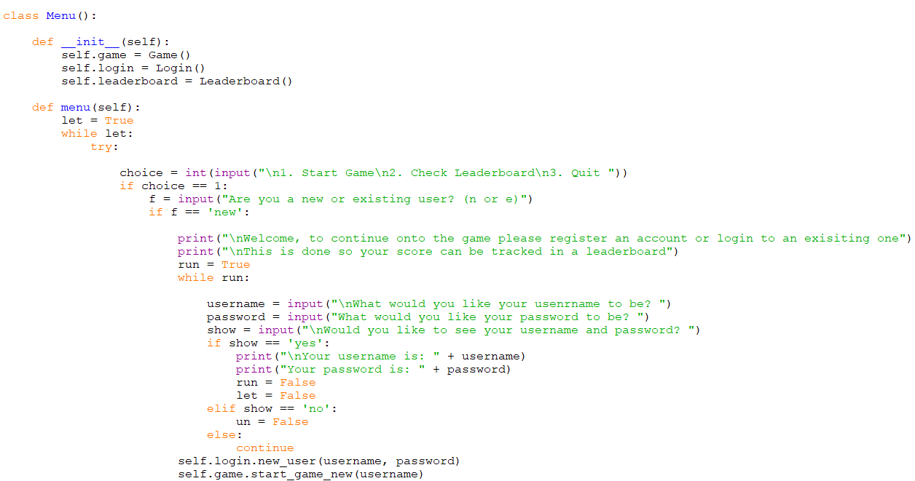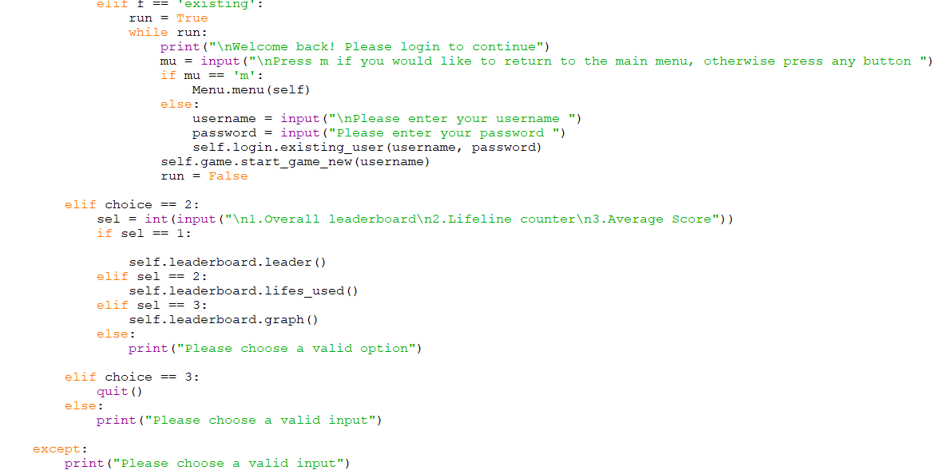

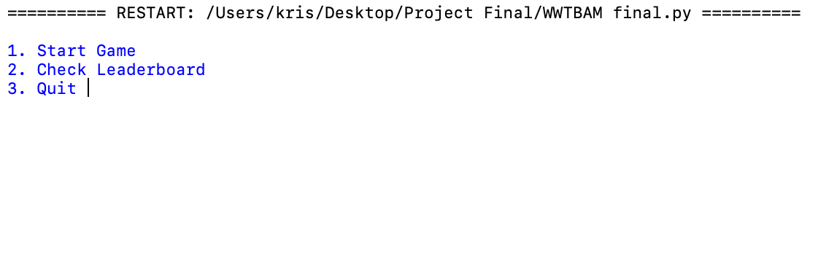

2.Allow the user to make a new account and store it in the SQLite database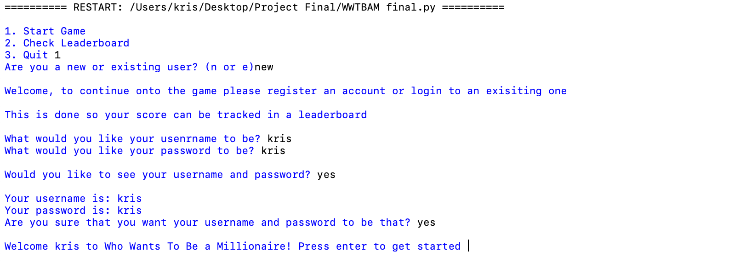

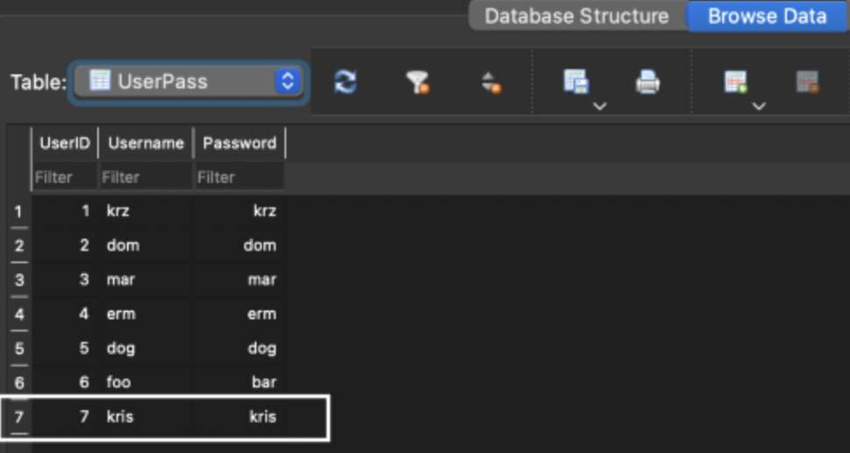

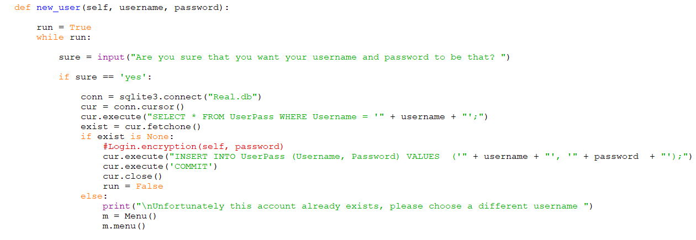

3.Allow a user with an existing account to log back in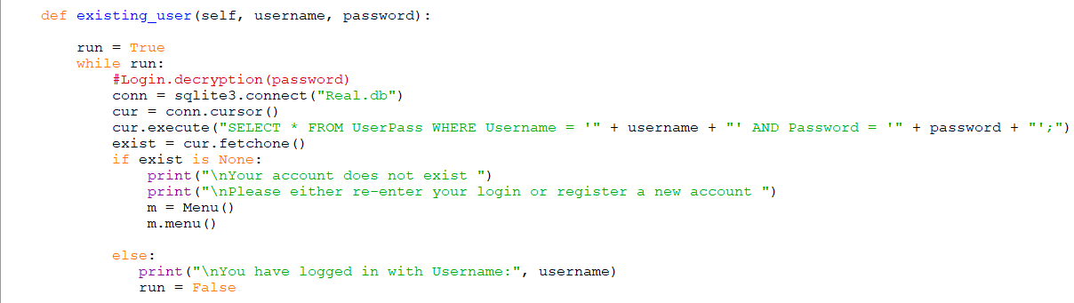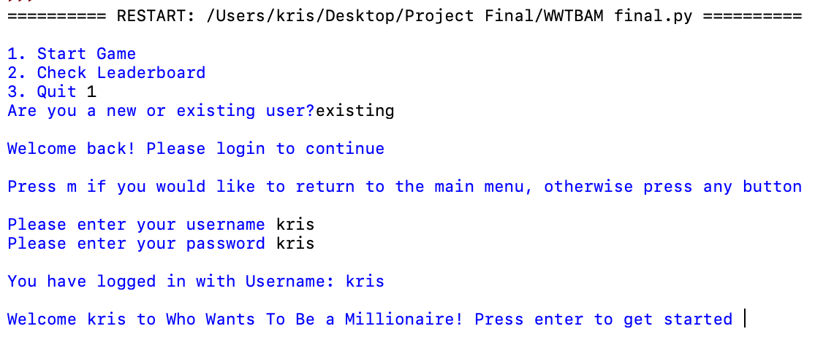

4. Check if username already exists and prevent the creation of another account if name already exists

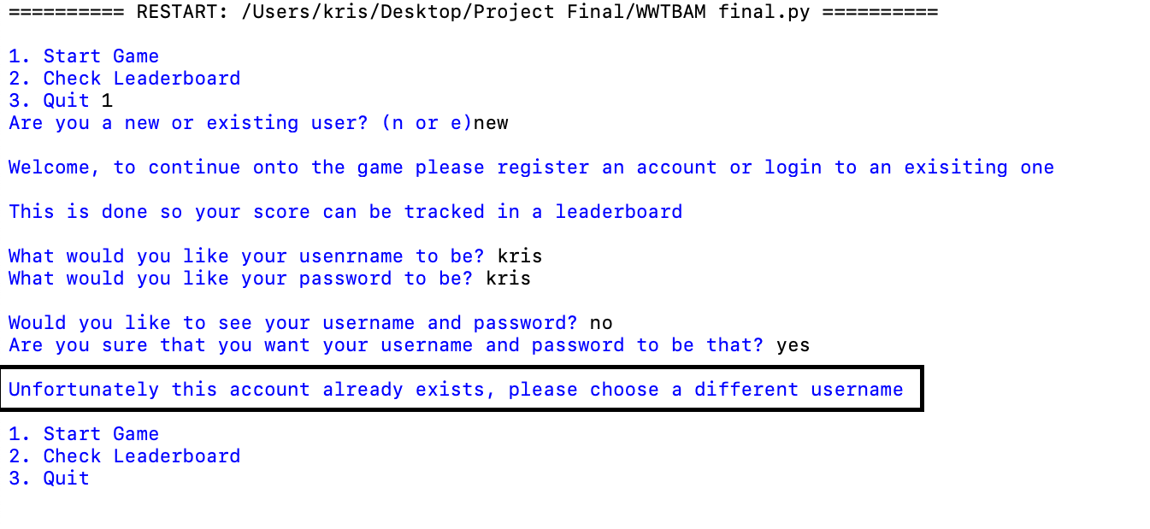

5. Based on the data the user provides the game will run until the end

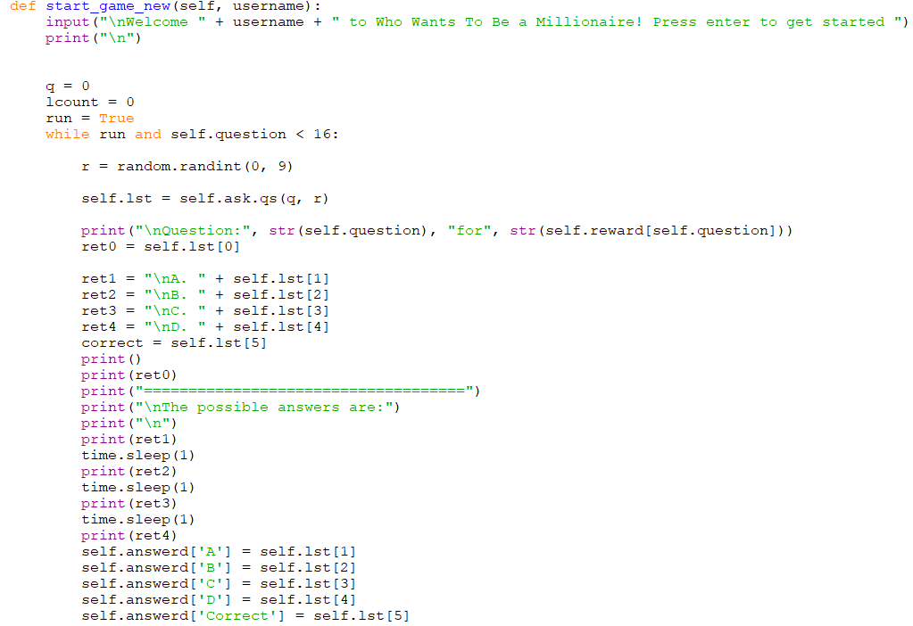

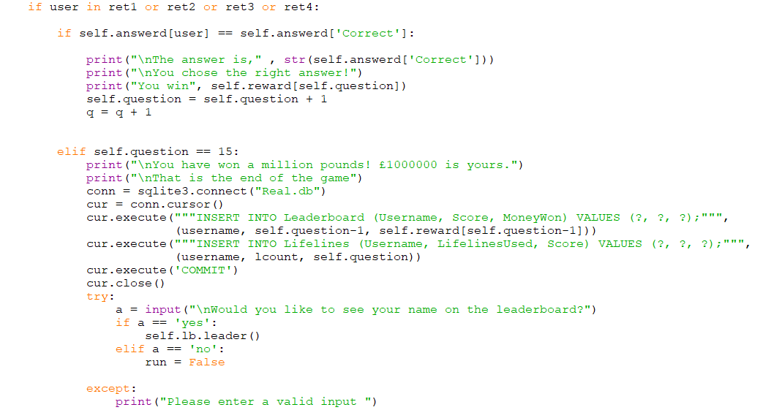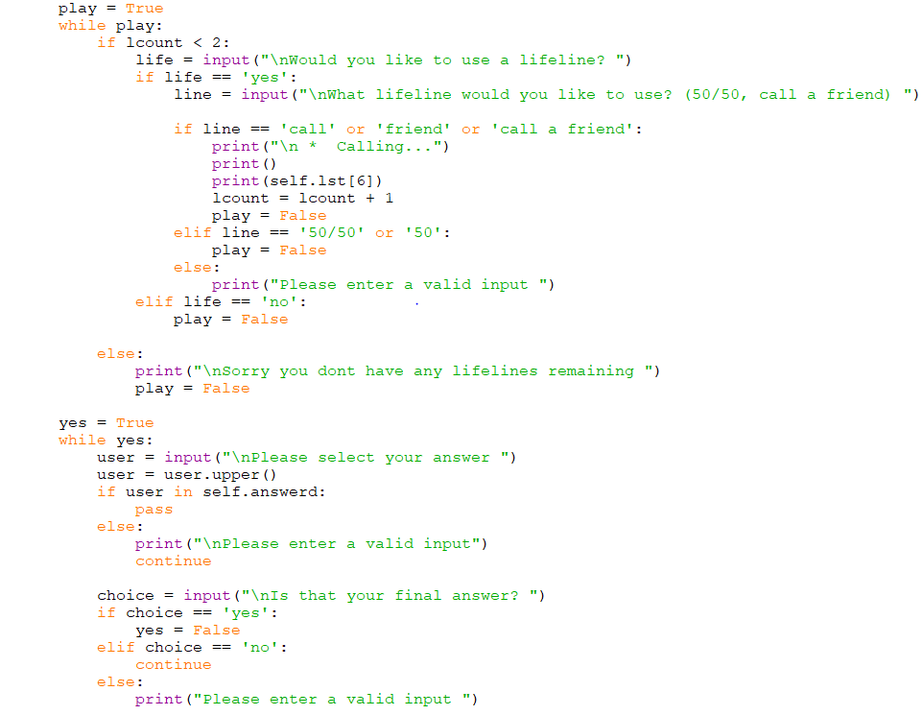

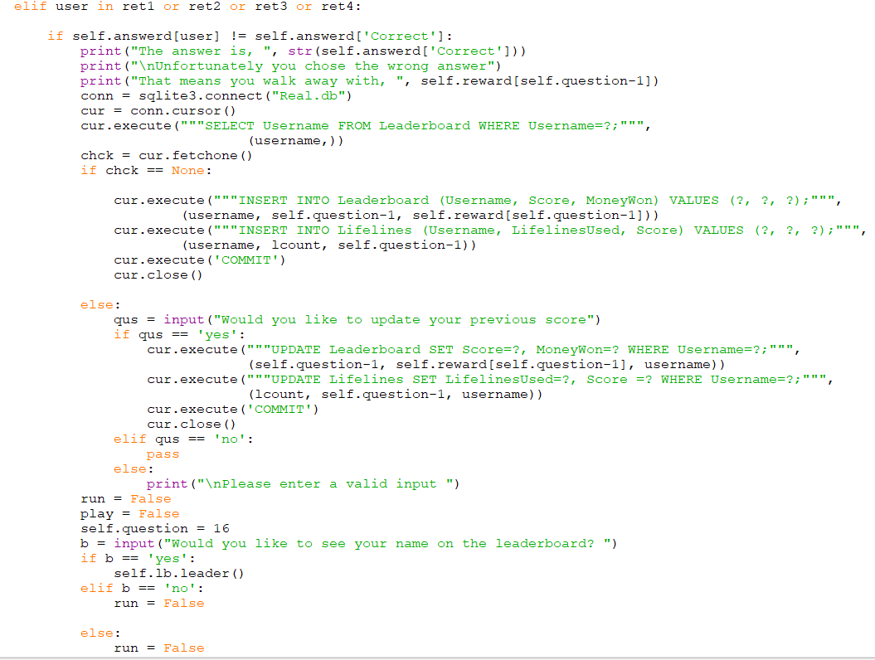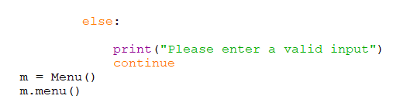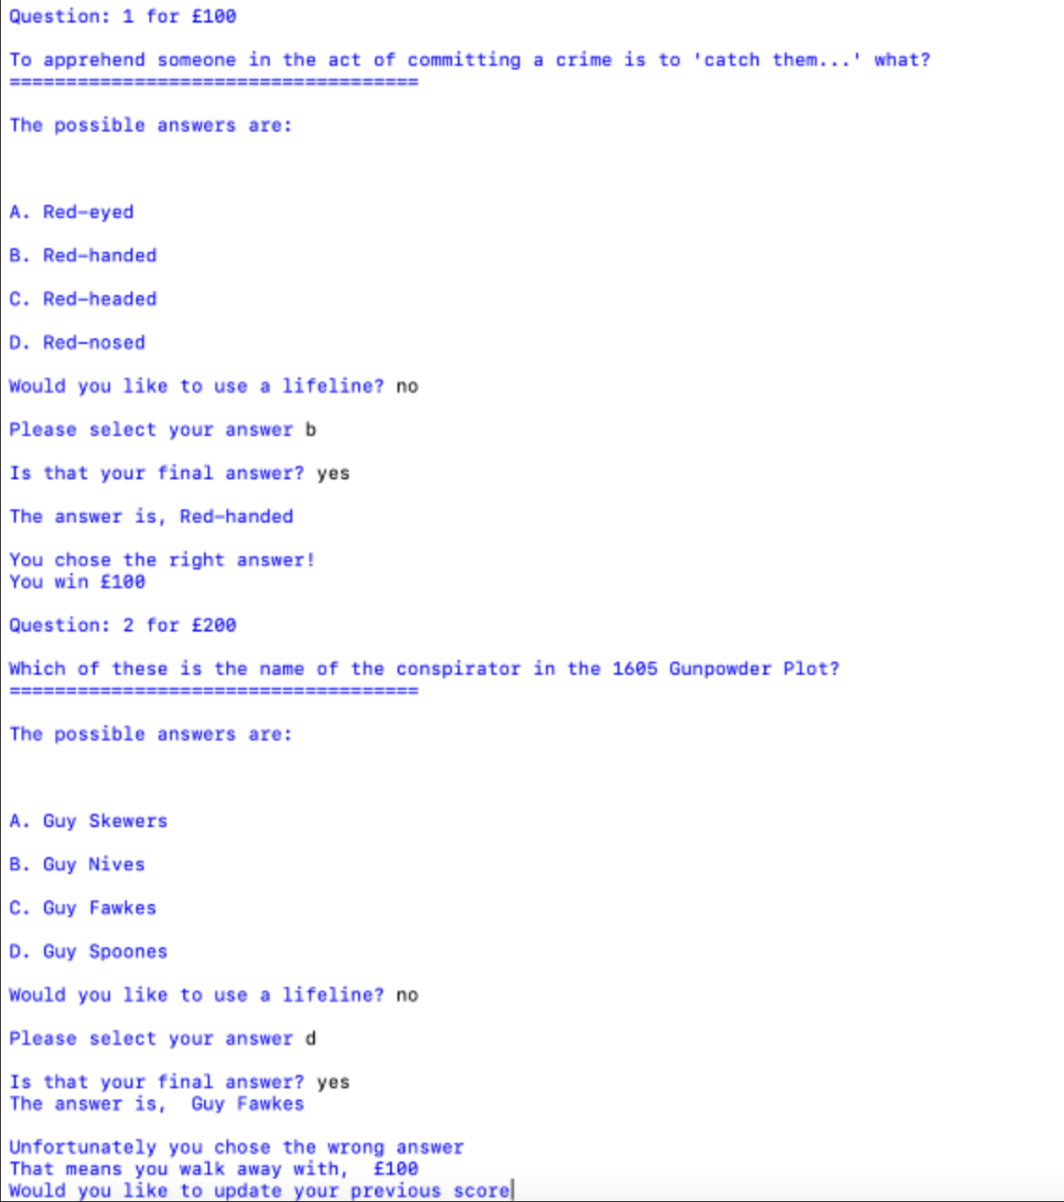

6. Full implementation of all lifelines

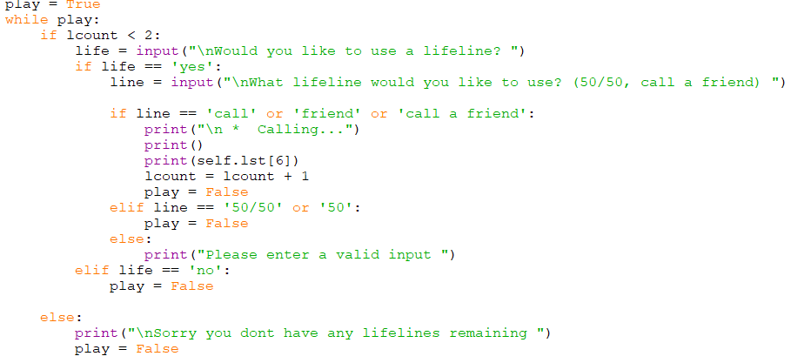

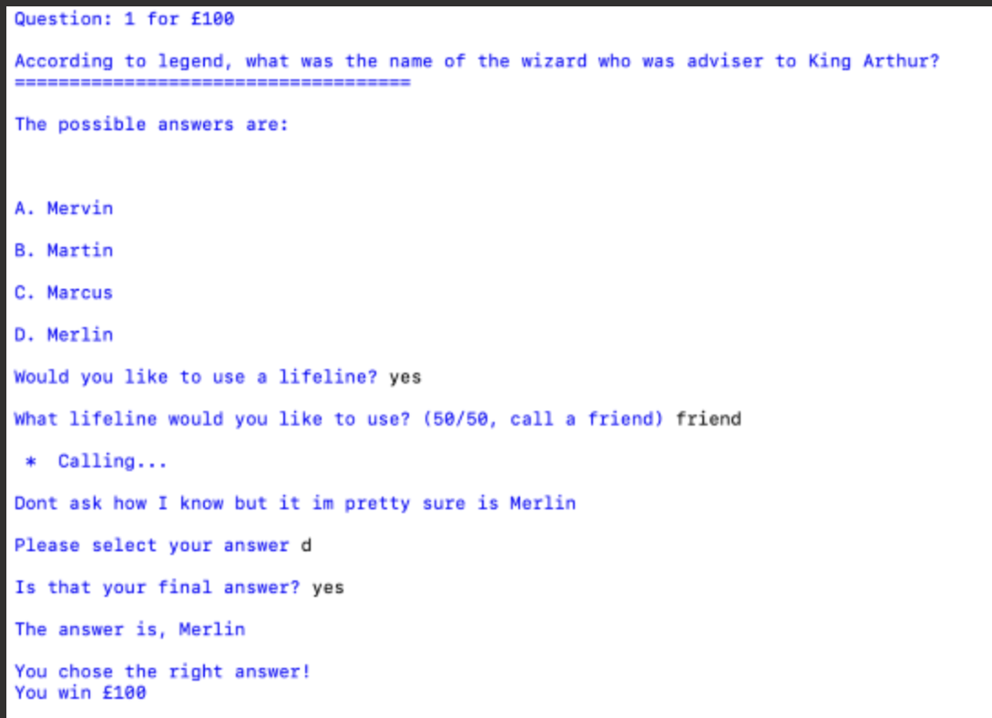

7. A returning user can choose to update their old score or keep the previous

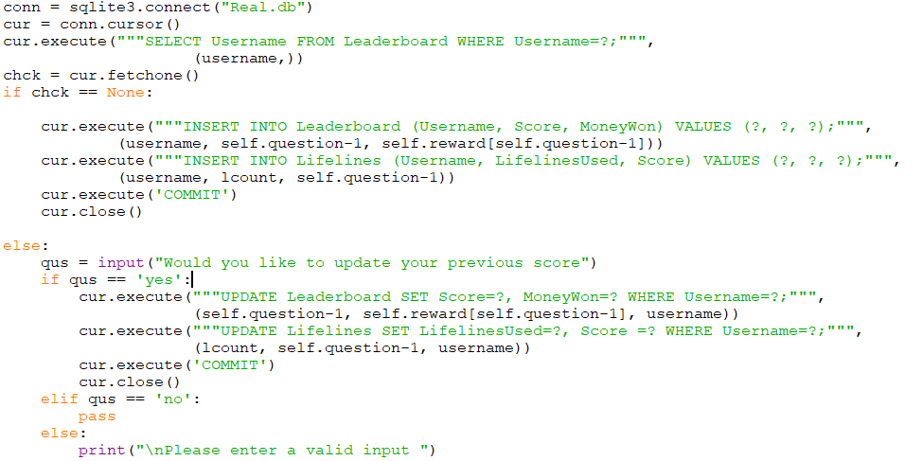

8. Produce a graph depending on the data stored in the database

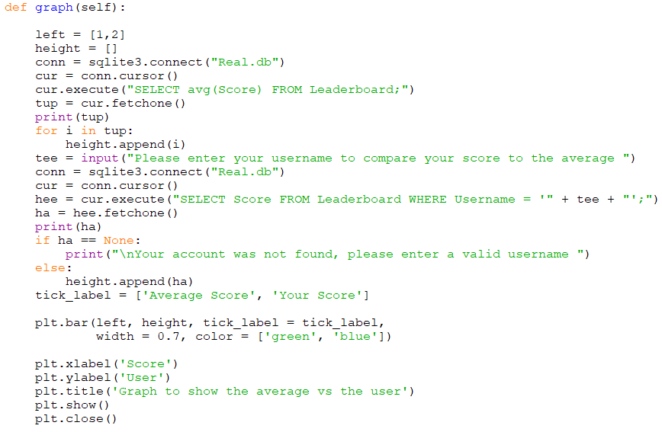

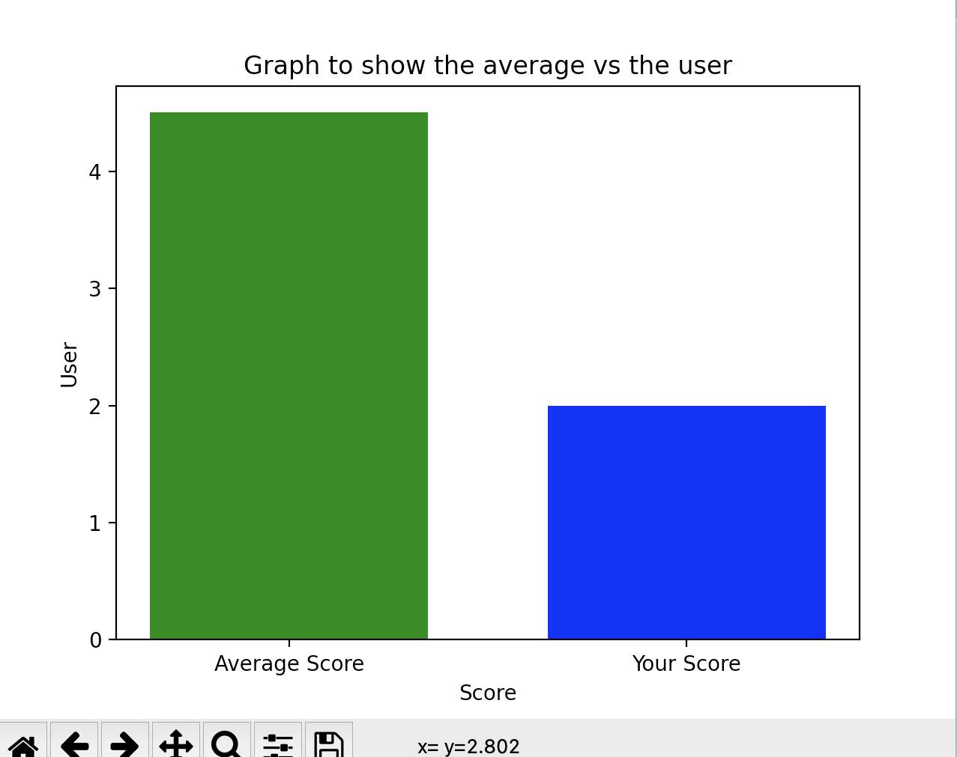

9. Produce a leaderboard on the data stored in the database

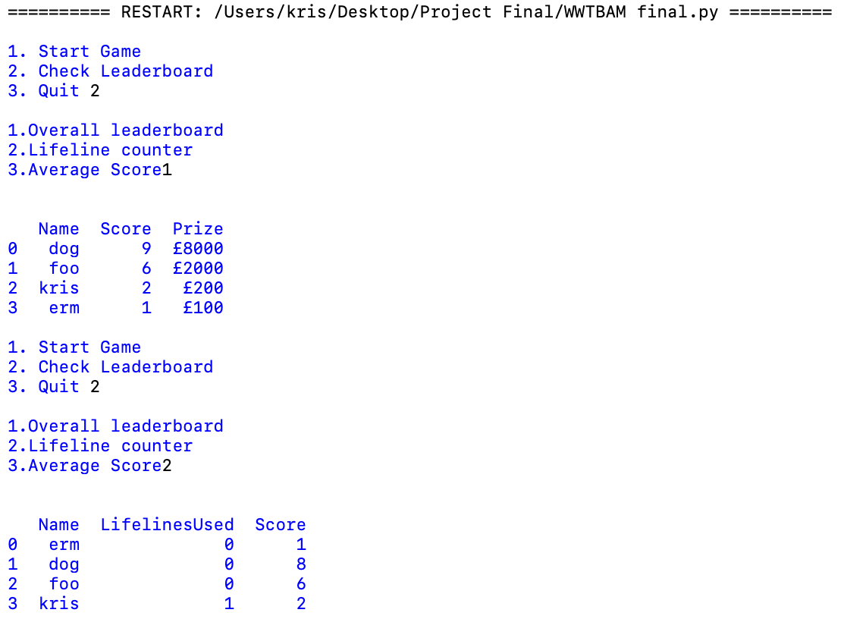

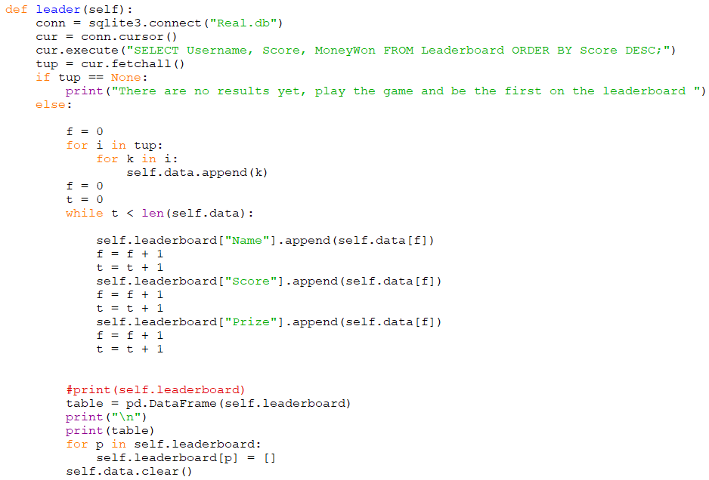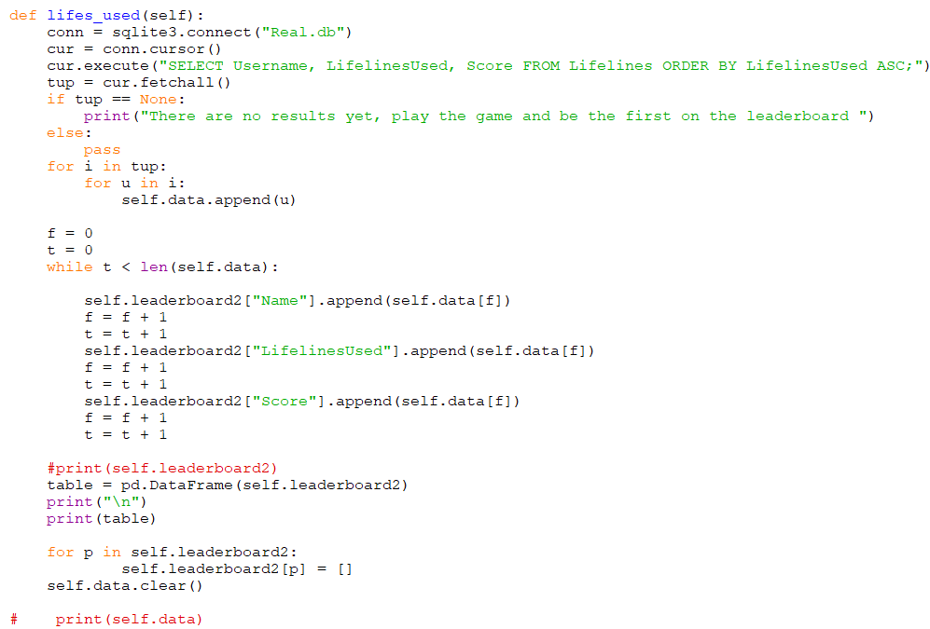

## Demonstration of complexity

### Group A

#### List operations

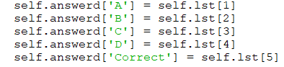

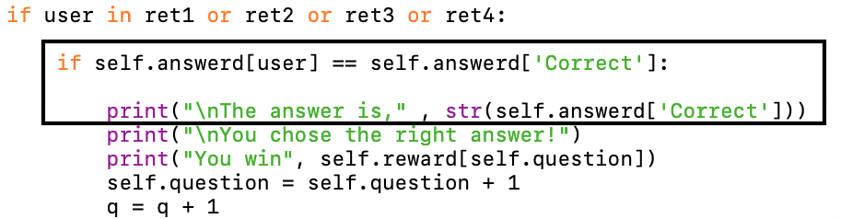

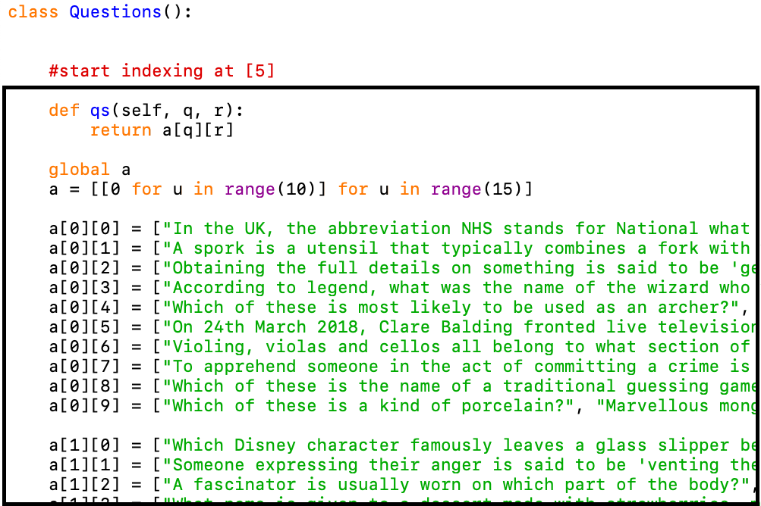

#### Complex OOP model

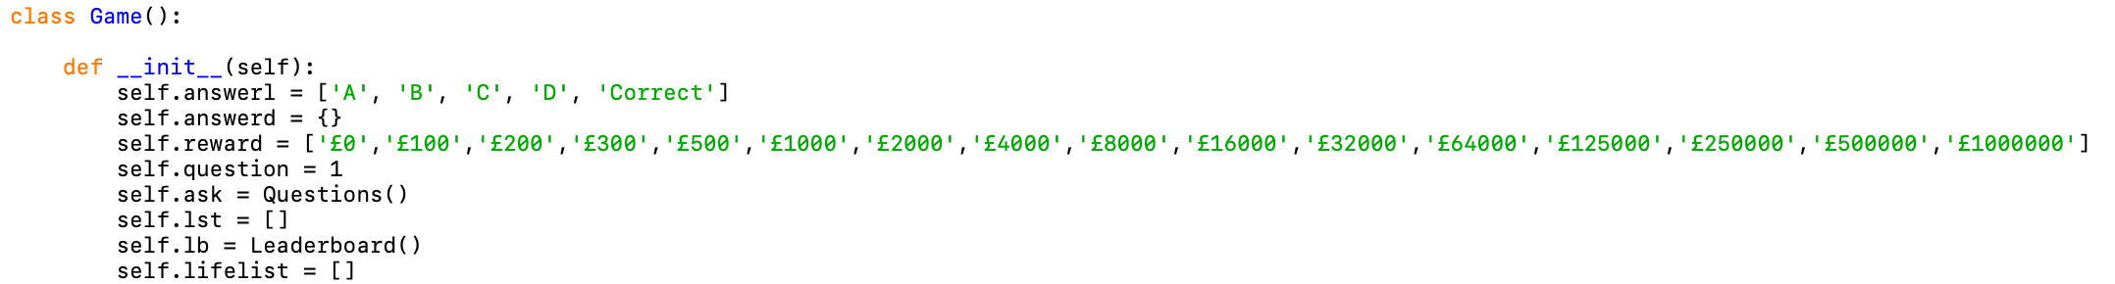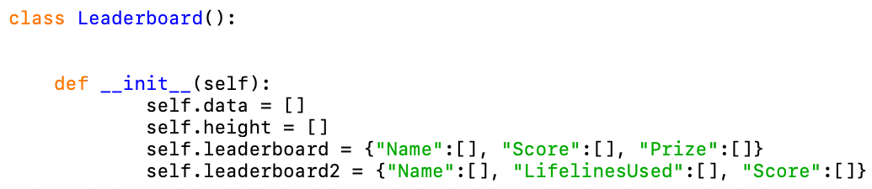

#### Complex database model

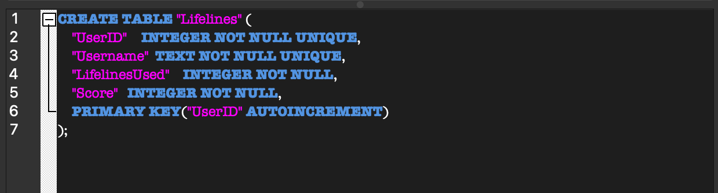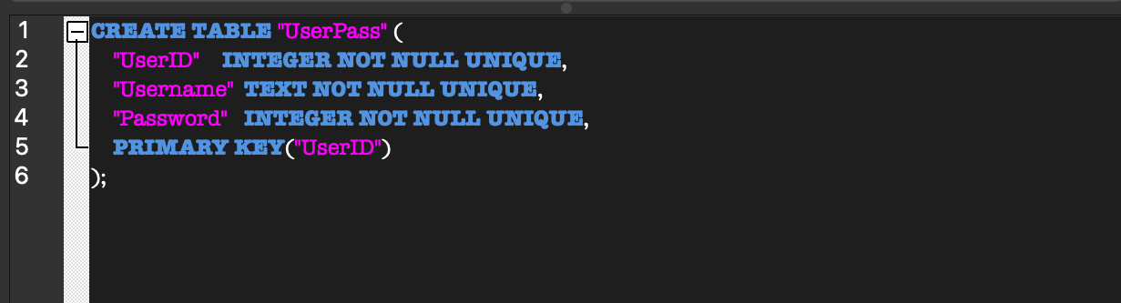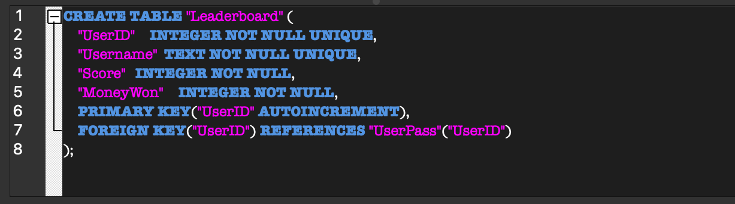

### Group B

#### Database model



#### Dictionaries and records

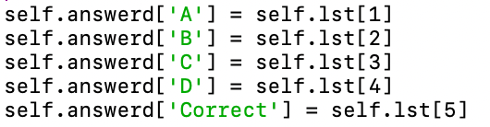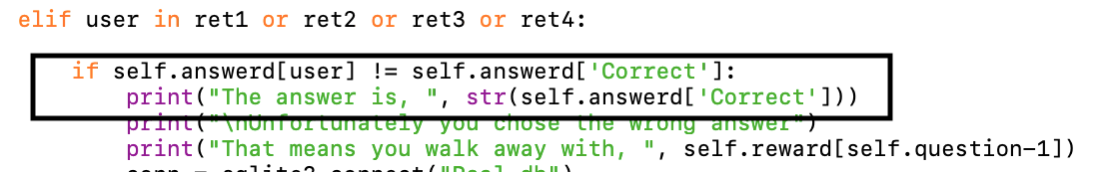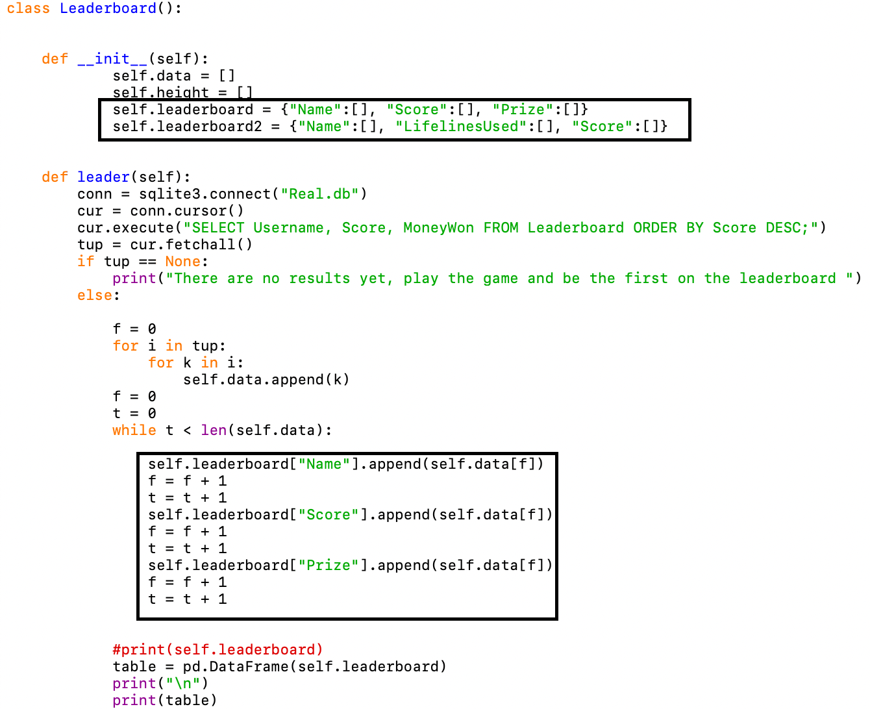

### Group C

#### Single dimensional array

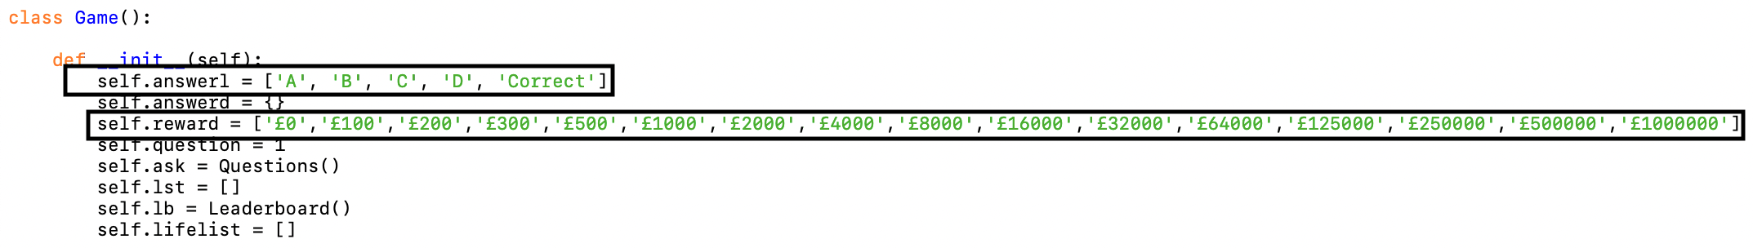

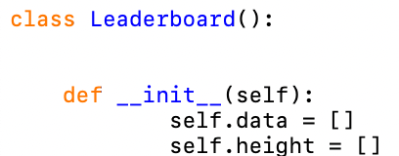

#### Appropriate choice of simple data types



## The whole solution

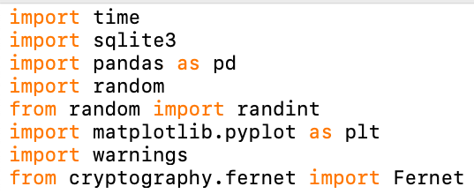

These are the libraries I am using in my program:

Time – used to delay the program when possible answers show

Sqlite3 – used to allow communication between my SQLite database and Python

Pandas – to allow the formatting to make a leaderboard in my program

Random/randint - used to give a random integer, this is used for selecting the next question

Matplotlib – to allow the creating of the graph in my program

Fernet – used in my attempt to encrypt the users password before it went into the database

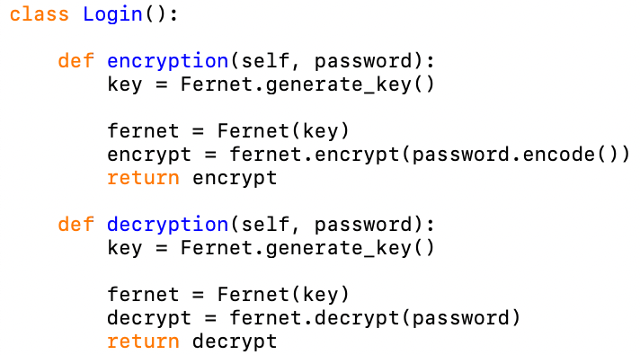

This is my login class, included in this class are the functions encryption, decryption, new_user and existing_user. In the screenshot above are two functions showing my attempt at making a function encrypting the users password before it goes into the database and then a function to decrypt when the user tries to log back in again. They were not successful which will be evaluated later.

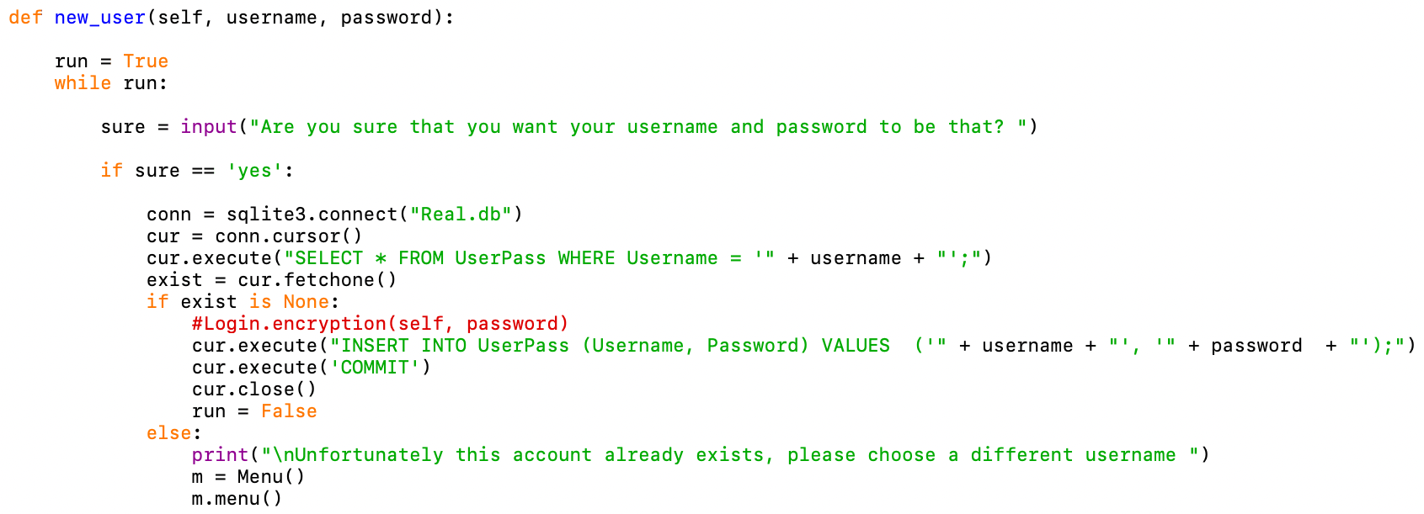This the new_user function, it is called later, in the menu class if a user wants to create a new account. The purpose of this function is to validate that the user wants to use the username and password they had set, this is shown by the sure variable. If the user answers ’yes’ then the username and password they have chosen for their account will be stored in the database. However, the program also has an else statement in case the username that has been chosen already exists, this will bring the user back to the menu where they must create a new account again but this time with another username.

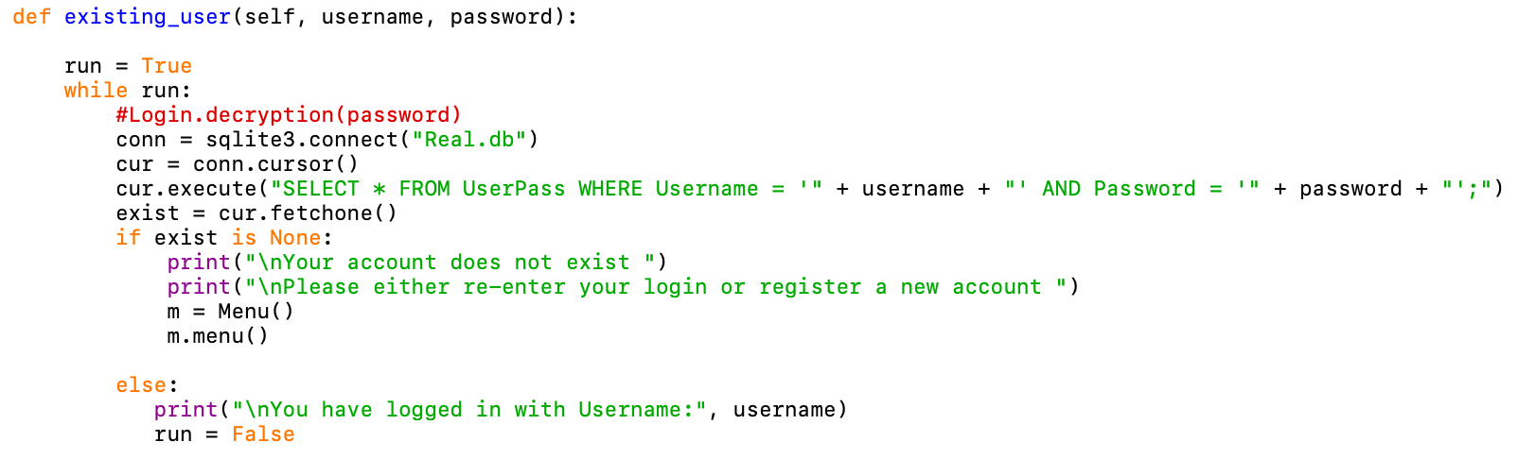This is the existing_user function, it is also called later in the menu class however it is if the user already has an existing account within the database. The function uses a SELECT statement to fetch the account that the user has inputted, if no account is returned then the account does not exist, and the user is returned to the menu where they can either try to login in again or make a new account. If the user enters an account that matches what is in the database, then they are logged in with that account. The comment (Login.decryption(password)) is where the decryption function would have been used if it had worked how I wanted it to, this will be evaluated later.

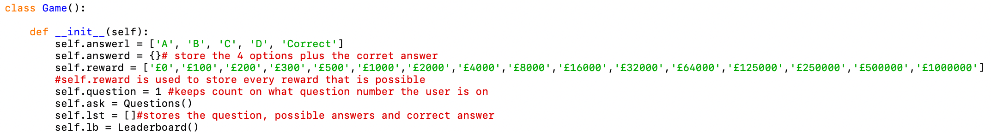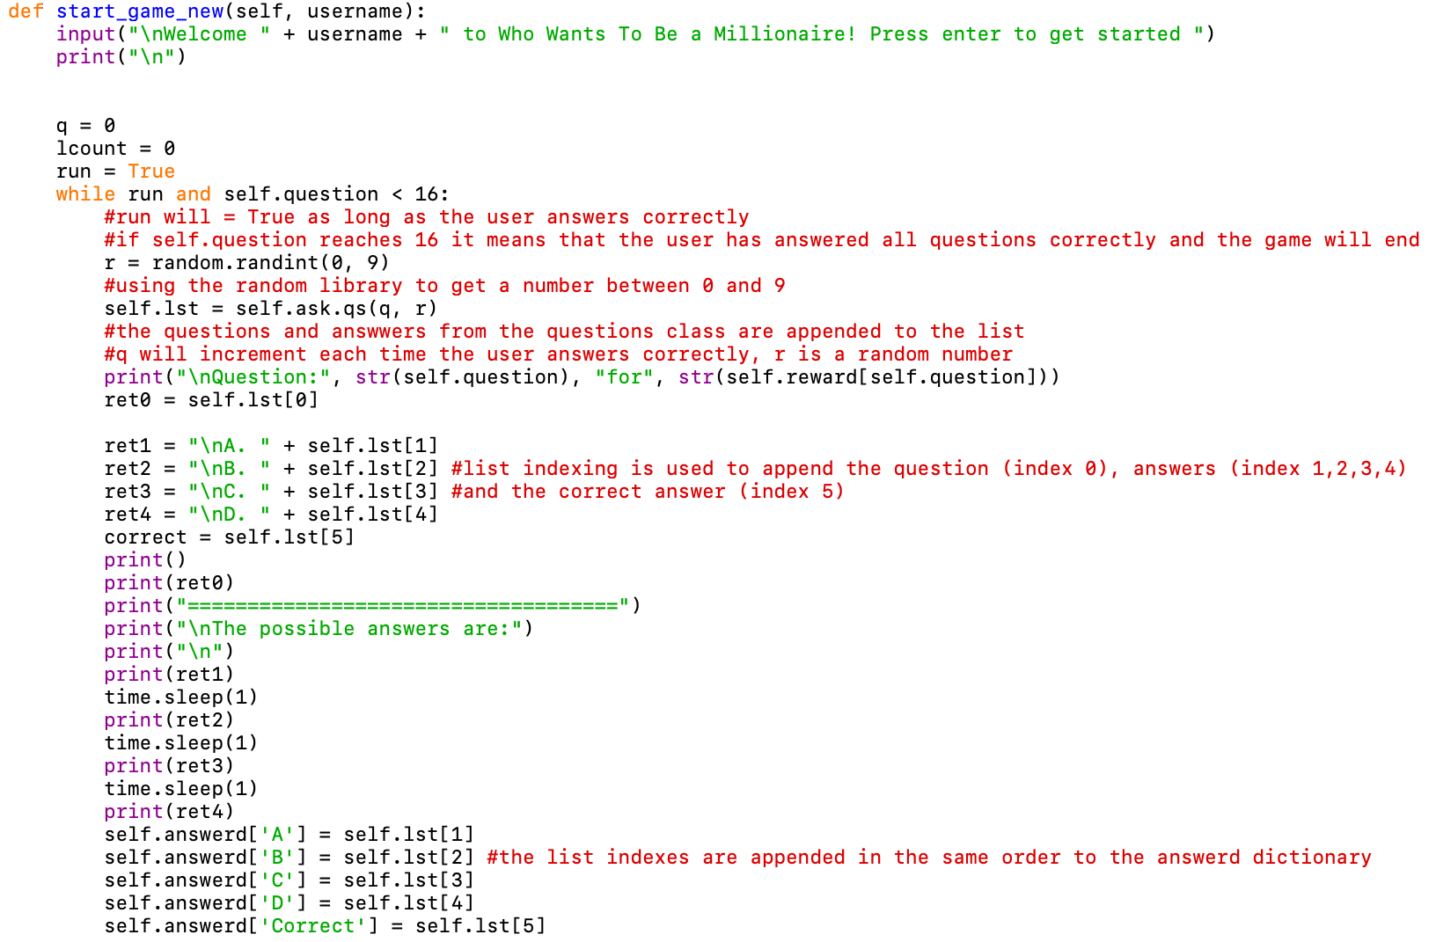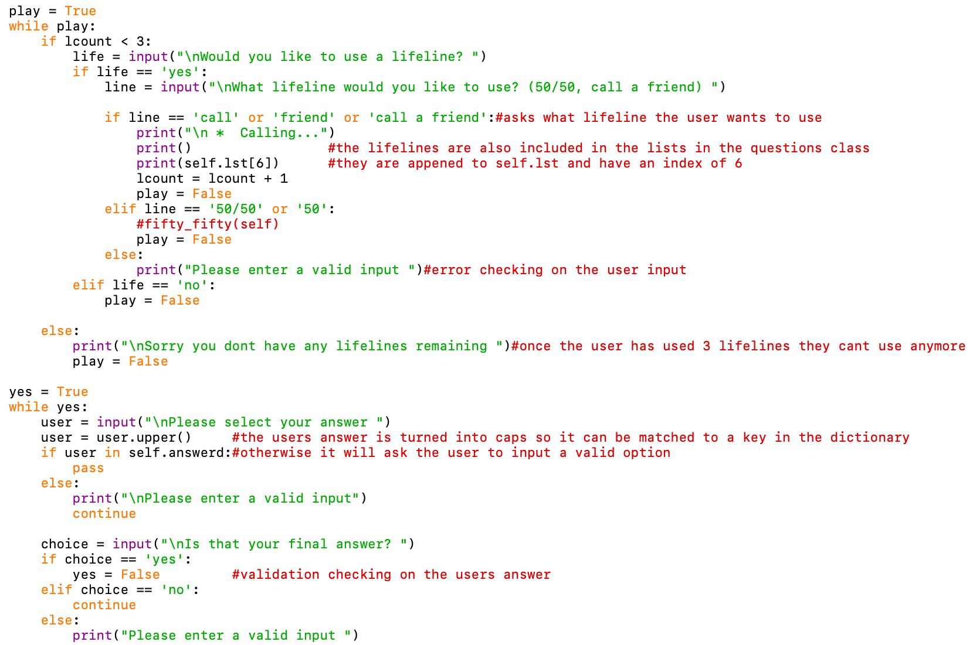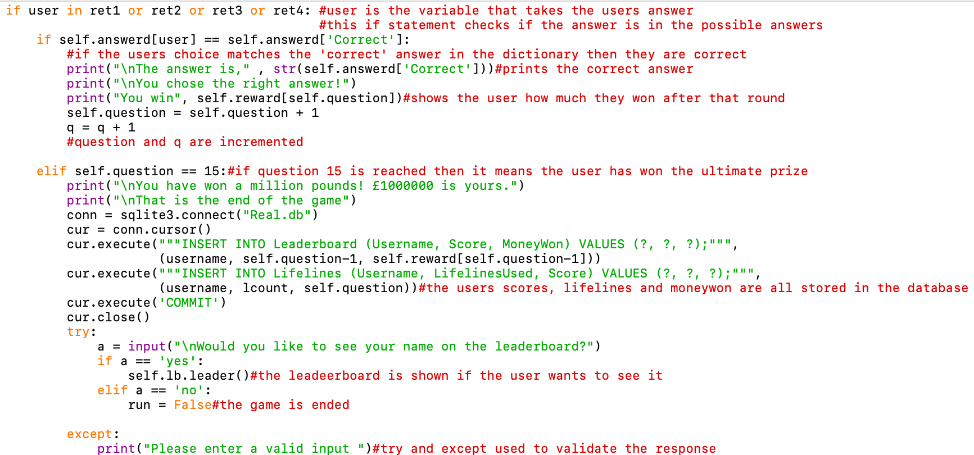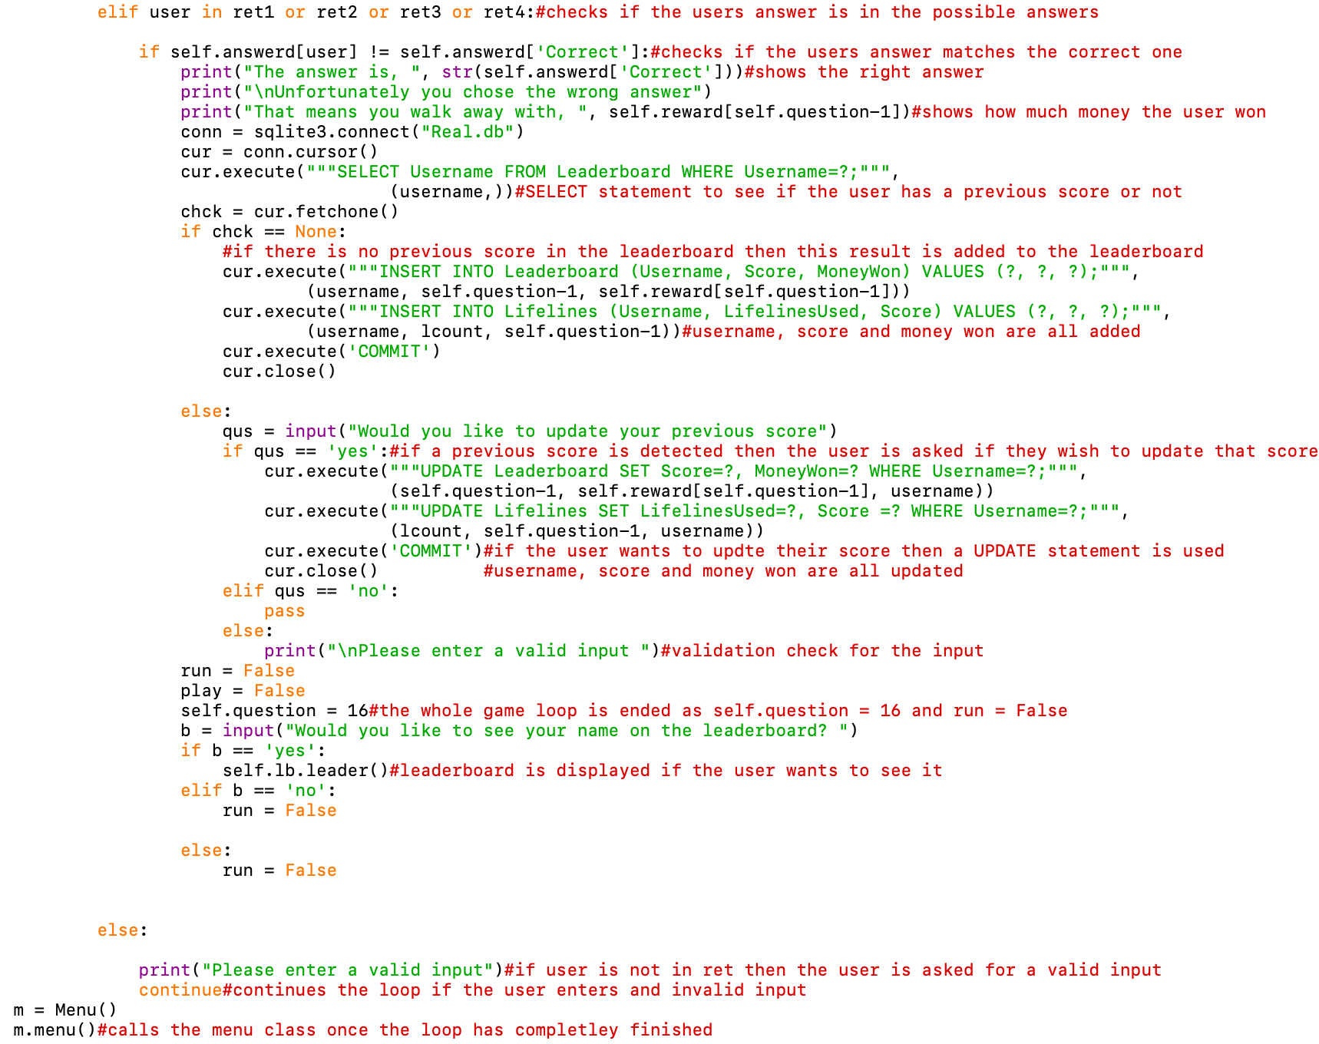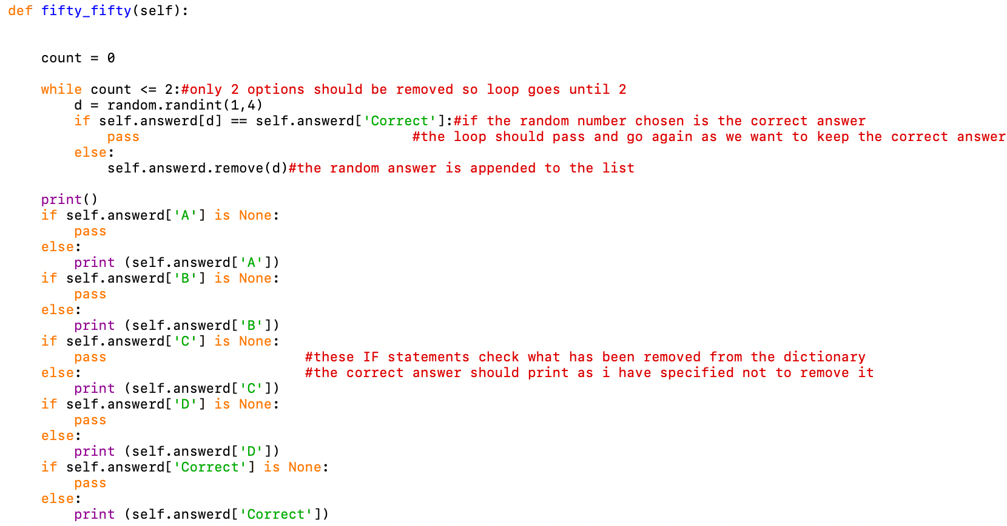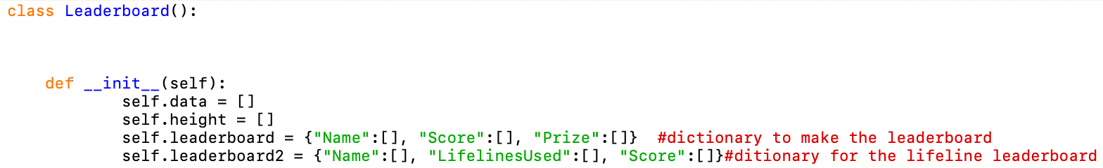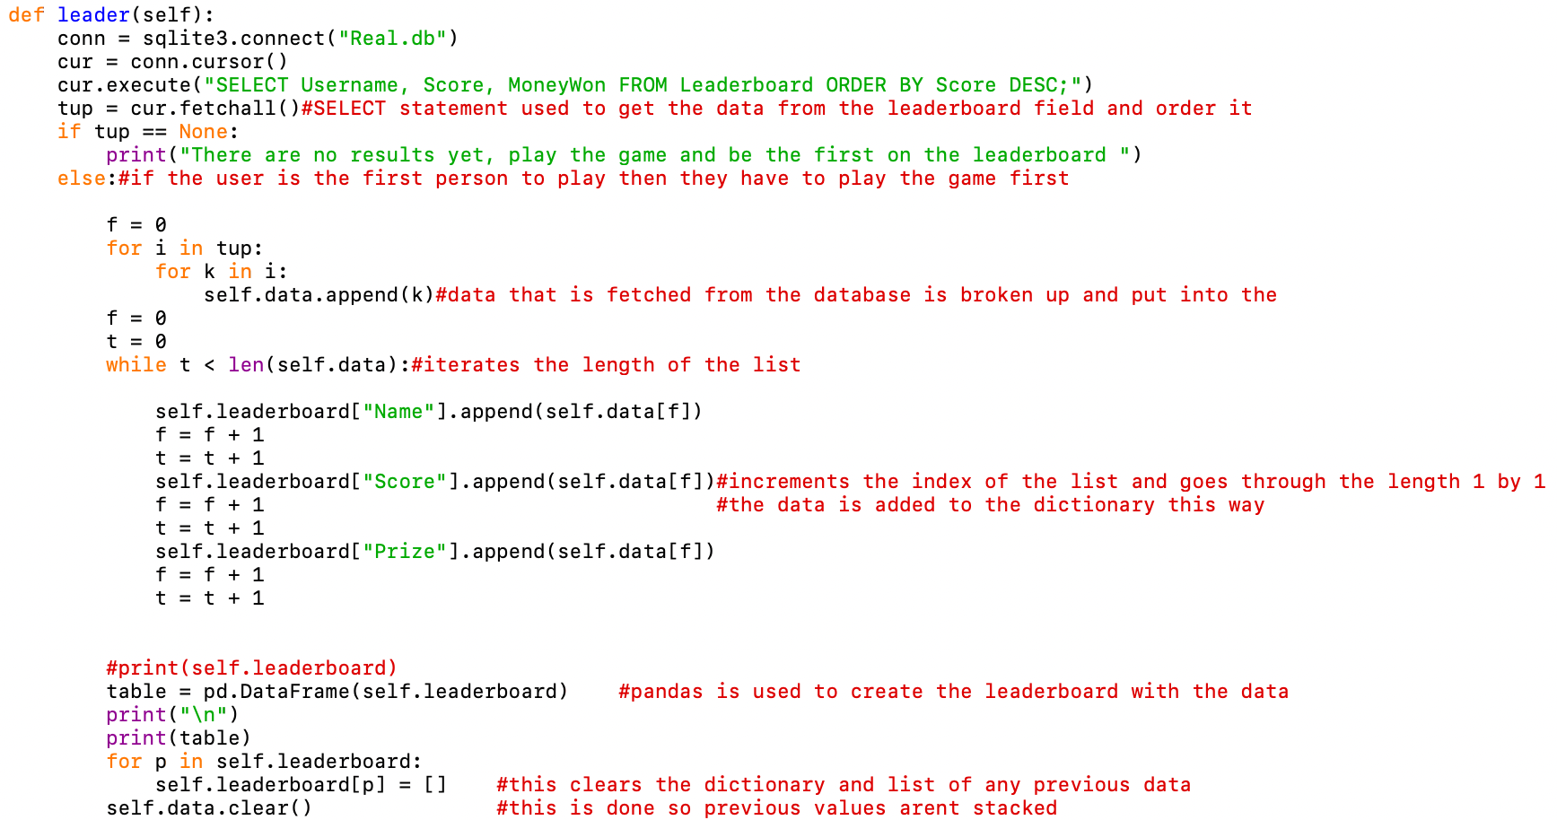

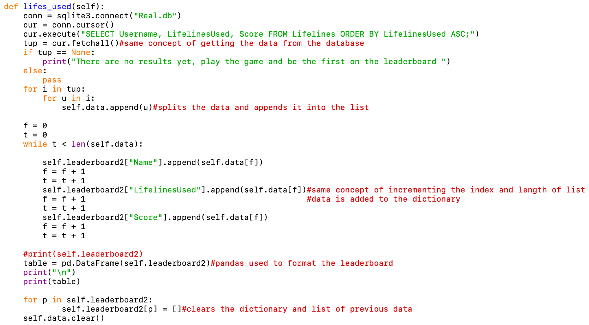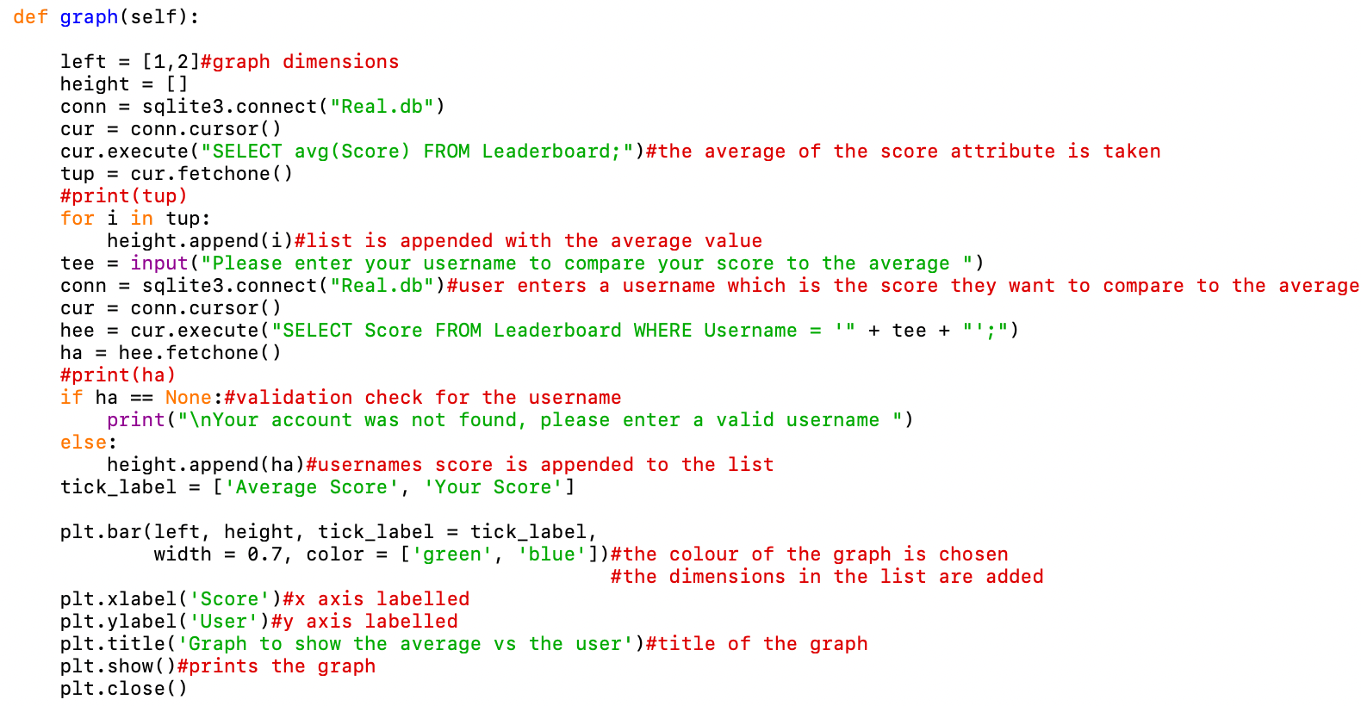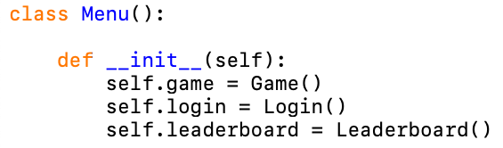

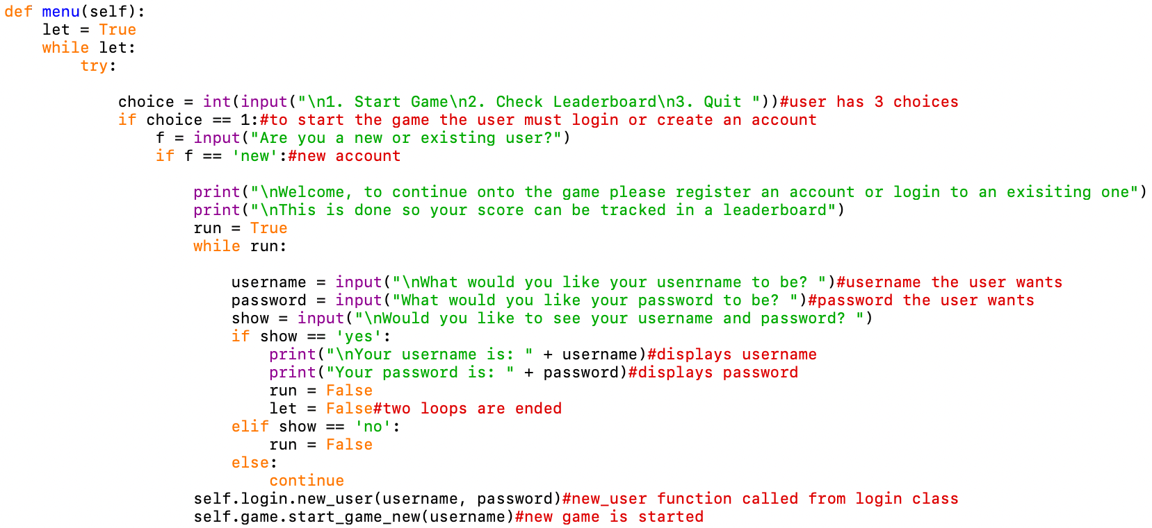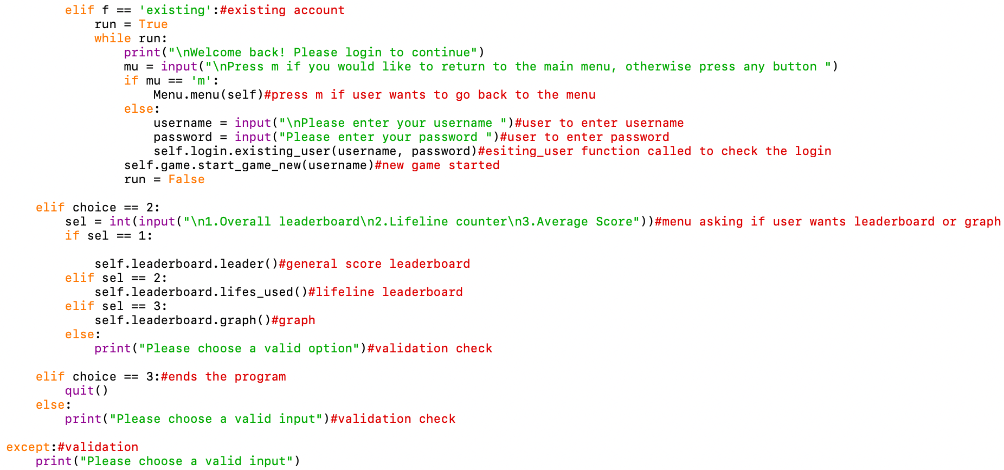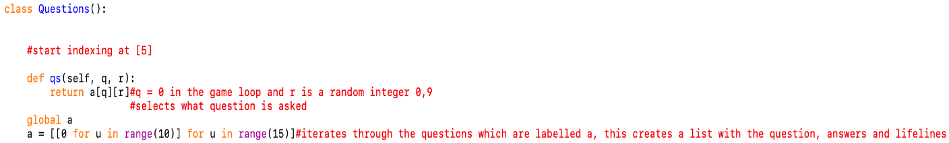

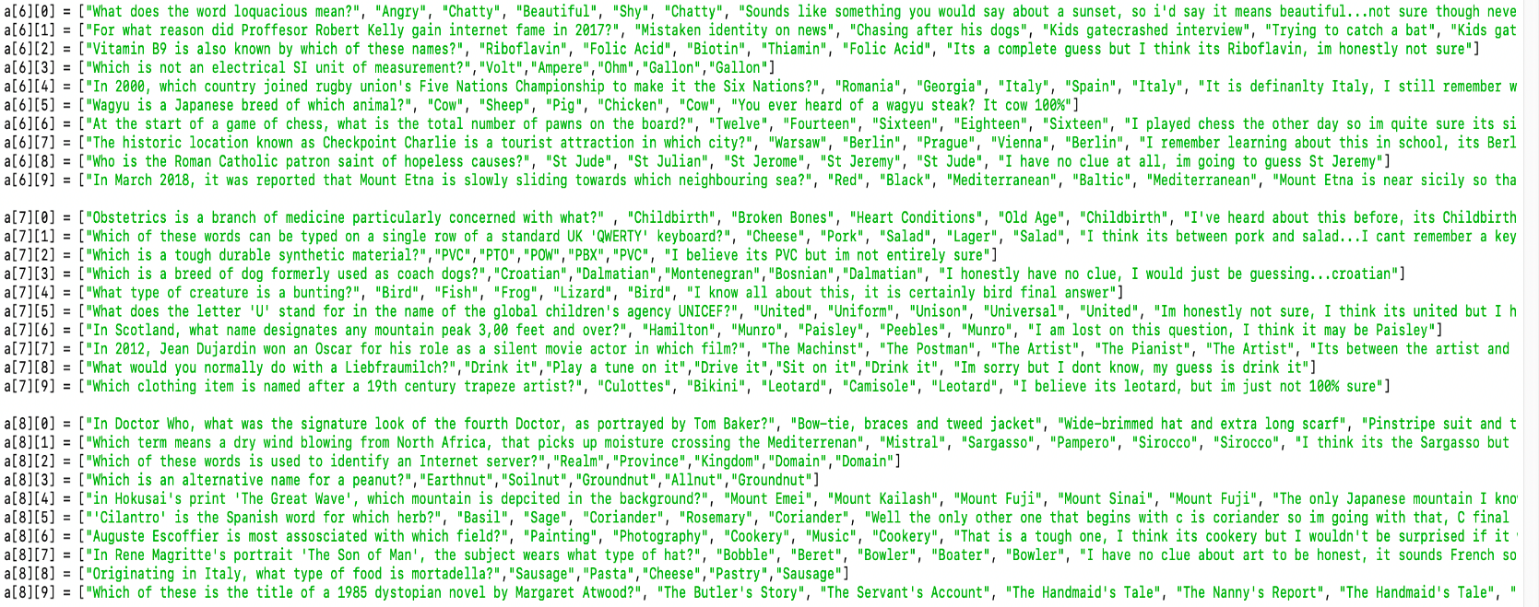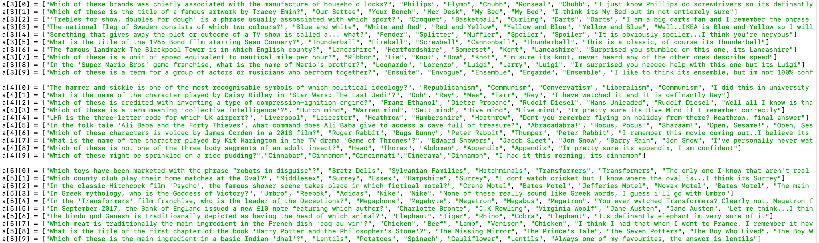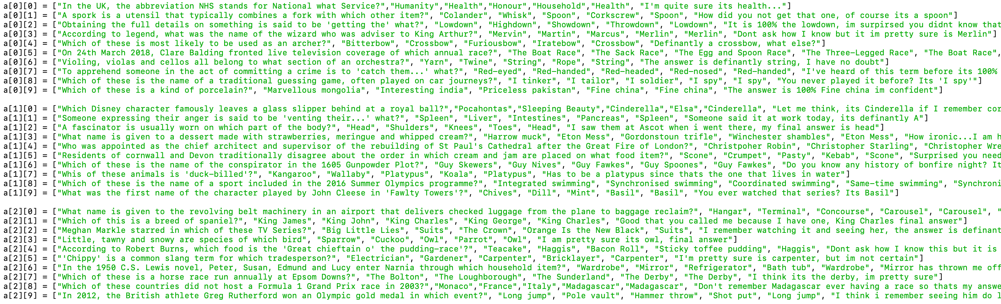

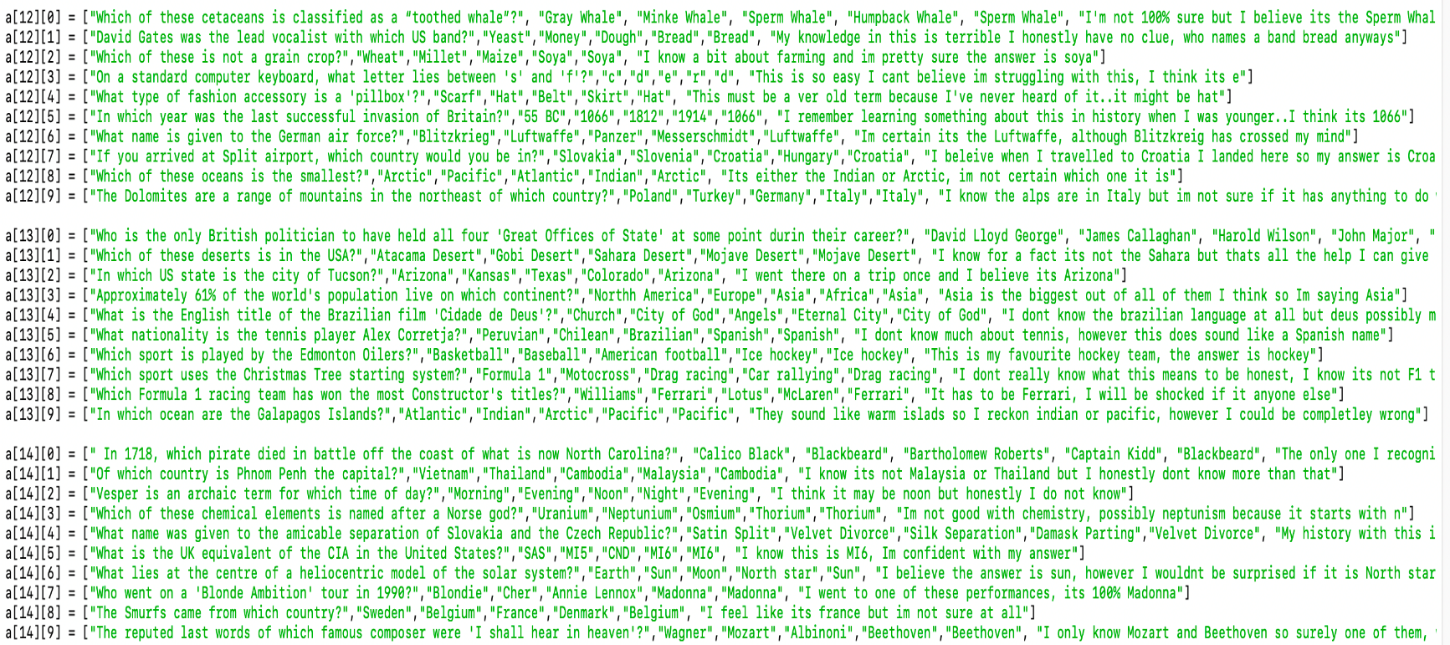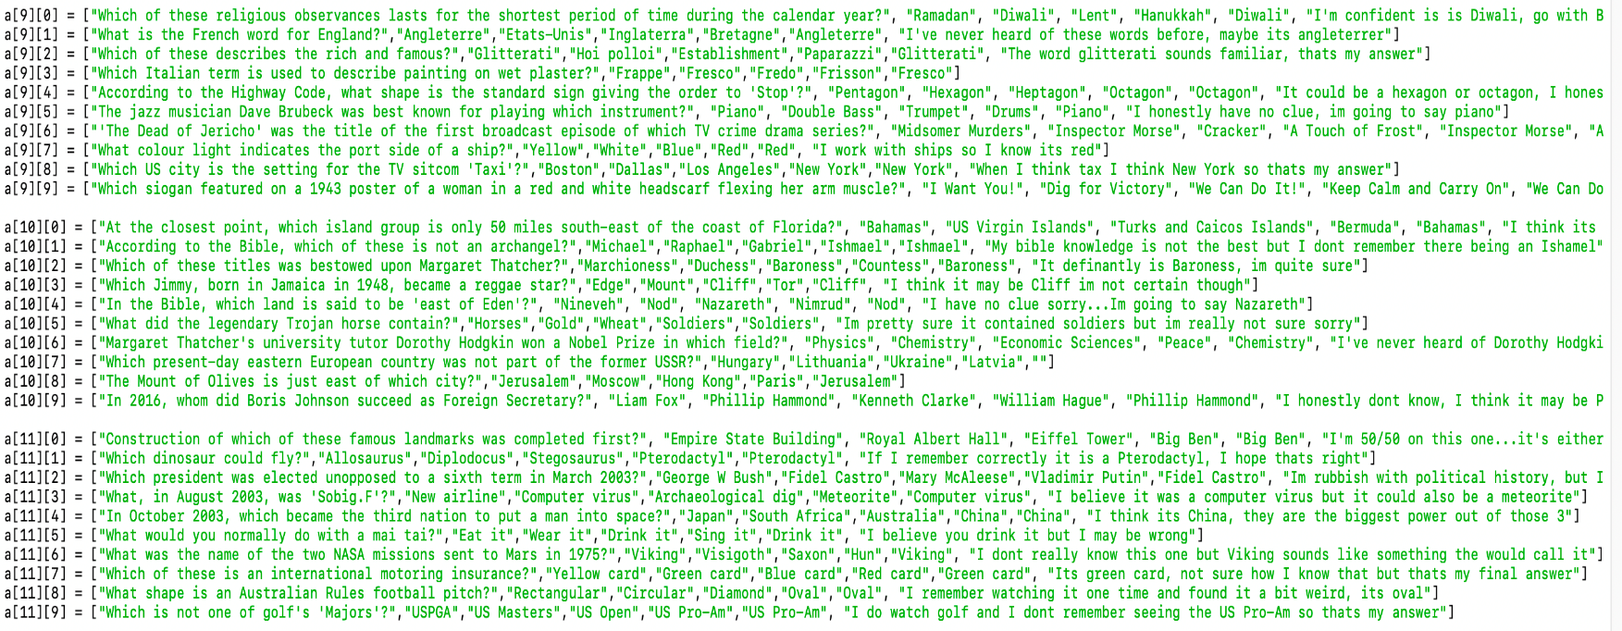

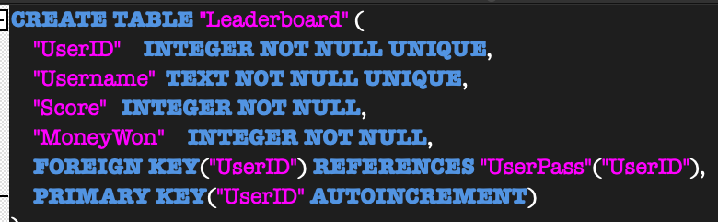

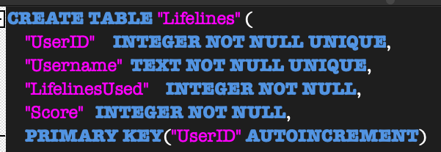

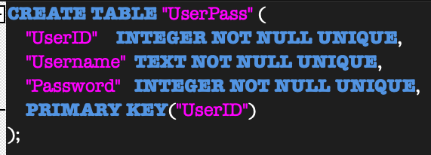

# Testing

To test my program I will use basic testing, this will let me test all the correct inputs along with random string or integer inputs that will check if an error comes up or whether it is handled correctly by the program.

## Basic tests

#### Test table (menu)

|  |  |  |  |  |  |
| --- | --- | --- | --- | --- | --- |
| Test | Description | Data type | Expected outcome | Successful/  fail | Screenshot |
| 1 | Choose option 1 on the menu | Typical | Start the login process | success | S1 |
| 2 | Choose option 2 on the menu | Typical | Go to the leaderboard/  graph table | success | S2 |
| 3 | Quit | Typical | End the program | success | S3 |
| 4 | Choose an option in the menu | Erroneous | Input should be disallowed | success | S4 |

#### Screenshot table (menu)

|  |  |
| --- | --- |
| Test | Screenshot |
| 1 |  |
| 2 |  |
| 3 |  |
| 4 |  |

#### Test table (login loop)

|  |  |  |  |  |  |
| --- | --- | --- | --- | --- | --- |
| Test | Description | Data type | Expected outcome | Successful/  fail | Screenshot |
| 1 | User selects to create a new account | Typical | User can create an account and the game starts | success | S1 |
| 2 | User selects to login to their existing user | Typical | User logs in to their existing account with the correct credentials and the game starts | success | S2 |
| 3 | User chooses a username that already exists in the database | Erroneous | User cannot choose this username and must make an account with a different name | success | S3 |
| 4 | User enters the wrong username/  Password when they are trying to login | Erroneous | The program returns to the menu and the user is asked to make a new account or login with the correct credentials | success | S4 |
| 5 | User enters an input other than new or existing when they are asked to make a new account or login with an existing one | Erroneous | User should be asked for a valid input | success | S5 |

#### Screenshot table (login loop)

|  |  |
| --- | --- |
| Test | Screenshot |
| 1 |  |
| 2 |  |
| 3 |  |
| 4 |  |
| 5 |  |

#### Test table (game loop)

|  |  |  |  |  |  |
| --- | --- | --- | --- | --- | --- |
| Test | Description | Data type | Expected outcome | Successful/  fail | Screenshot |
| 1 | If user says yes to a lifeline then they are presented with an option for a lifeline | Typical | **Yes** – question comes up to ask what lifeline to use  **No –** game continues and the user is asked for their answer | success | S1 |
| 2 | The user should be able to choose the lifeline (call a friend) | Typical | If friend is chosen then a statement is shown to help the user | success | S2 |
| 3 | The user should be able to choose the lifeline (50/50) | Typical | 2 incorrect options should be removed and there should be 1 correct option left with 1 incorrect | fail | S3 |
| 4 | The user doesn’t specify if they want to use a lifeline or not (yes or no) | Erroneous | The user should be asked again if they want to use a lifeline until specified | success | S4 |
| 5 | The user needs to choose an answer (A, B, C, D) | Typical | The program goes to the next phase and checks if the user is correct | success | S5 |
| 6 | The user chooses a different answer instead of one that is available | Erroneous | The program should ask for a valid input and the program won't continue until one is given | success | S6 |
| 7 | The user is asked if they are sure about their answer | Typical | If they are sure the answer is submitted, if not then they are asked for their answer again | success | S7 |
| 8 | User is asked if they are sure about their answer | Erroneous | The user is asked again for their answer if they enter an invalid input | success | S8 |
| 9 | If the user is correct, they should be congratulated, and the next question appears | Typical | The next question is asked | success | S9 |
| 10 | If the user is incorrect they should be told how much they have won | Typical | The user should be asked if they want to update their score if they don’t have a previous score, otherwise their score will be inputted into the leaderboards | success | S10 |
| 11 | The user answers all questions correctly and wins the ultimate prize | Typical | The user gets the winning message and then asked if they want to see the leaderboard | success | S11 |
| 12 | The user wants to update their previous score | Typical | The users new score gets put into the leaderboards and overwrites the old | success | S12 |
| 13 | The user doesn’t want to update their score | Typical | The user gets asked if they want to see the leaderboard | success | S13 |
| 14 | The user doesn’t enter a valid choice | Erroneous | The question gets asked again for a valid input | fail | S14 |
| 15 | User is asked if they want to see the leaderboard (yes) | Typical | Leaderboard prints in a descending order (score) | success | S15 |
| 16 | User is asked if they want to see the leaderboard (no) | Typical | The program returns to the menu | success | S16 |
| 17 | User is asked if they want to see the leaderboard | Erroneous | User is returned to the main menu | success | S17 |

#### Screenshot table (game loop)

|  |  |
| --- | --- |
| Test | Screenshot |
| 1 |  |
| 2 |  |
| 3 |  |
| 4 |  |
| 5 |  |
| 6 |  |
| 7 |  |
| 8 |  |
| 9 |  |
| 10 |  |
| 11 |  |
| 12 |  |
| 13 |  |
| 14 |  |
| 15 |  |
| 16 |  |
| 17 |  |

#### Test table (leaderboards and graphs)

|  |  |  |  |  |  |
| --- | --- | --- | --- | --- | --- |
| Test | Description | Data type | Expected outcome | Successful/  fail | Screenshot |
| 1 | User selects option 1 to view the overall leaderboard | typical | The graph should show in descending order (score) | success | S1 |
| 2 | User selects option 2 to view the lifeline leaderboard | typical | The graph should show in descending order (LifelinesUsed) | success | S2 |
| 3 | User selects the graph option to show a users score vs the average score of all users | typical | User should be asked what account name they want to take the score from | success | S3 |
| 4 | User selects an option on the menu | erroneous | The user should be returned to the main menu | success | S4 |
| 5 | User is asked what account they want to take the score from | typical | Graph should show the average score vs the chosen users score | success | S5 |
| 6 | User is asked for an account name | erroneous | Message should pop up saying that account doesn’t exist or has no result | success | S6 |

#### Screenshot table (leaderboards and graphs)

|  |  |
| --- | --- |
| Test | Screenshot |
| 1 |  |
| 2 |  |
| 3 |  |
| 4 |  |
| 5 |  |
| 6 |  |

## General testing

General testing will include any problems that I have not had the time to fix and amend, some problems didn’t work because of the code, and some didn’t work because of the way they had implemented.

### Known issues

One known issue is that the encryption and decryption of the password is not implemented in the program, the code for the two functions is in my screenshots and pseudocode as they do work on my code, however they don’t work well in the given context of the code. By this I mean when encrypting the password, a key is generated to encyrpt the password which works correctly. Also, if the program does not close the program window, then the user can log back in with the same account as the same key is used to decrypt the password. However, problems arise when you close and exit the program. This is because the key is random and changes every time you open the program again, this means if someone made an account and then closed the program, and then tried logging back in would not be allowed as the decryption key would be different to the original key that encrypted the password and therefore a different result would be returned so the original password would not be retrieved and the use wouldn’t be granted access with that account as they can’t log in.

I tried fixing this by setting the key to a set value so that the encryption and decryption key would be the same every time, however this didn’t work as they key kept returning an error. The errors included the encoding of the key and library didn’t like that I had made a set key and the format it was in, I couldn’t get it to work so I went back to the original (generate_key()) function as that original code did work but just not in the context I wanted it to.

Another issue was the implementation of the 50/50 lifeline, again the function is in the code to prove me testing and trying the function. The reasons for it not working were because I couldn’t tell where the correct answer was in the answer list, by this I mean that I could keep the correct answer from the dictionary as a test to see if the user was correct however, I couldn’t tell where the correct answer was in terms of A, B, C, D and because it kept changing I couldn’t program it to always keep a correct answer (in terms of A, B, C, D) so this function is not good enough to use in my program as it interrupts the sequence of the game.

### User experience

The overall user experience has been positive, the game flows how it should and the added feature of the delay between answers showing up is a good one. Users also like that their results are stored in a database and can be compared to other users, the leaderboard makes it easy to see how they rank amongst each other.

However, the user interface is text based and slightly uneventful, there is only so much that can be done with a text-based solution when it comes to presentation compared to a pygame solution for example. Also, the missing 50/50 lifeline is a hit on the program as it is a key part to WWTBAM and important to the game functioning authentically.

# Evaluation

|  |  |  |
| --- | --- | --- |
| **Objective** | **Completed?** | **Evaluation** |
| The program should accept a returning user | yes | The database is checked to see if the account does exist based off what the user inputted for their username and password. If it exists the user can continue to the game, otherwise the user is asked to try again or create a new account. |
| The program should let the user create a new account | yes | If the user is happy with the choice of username and password they can make a new account. The database is checked for an account that is existing and has the same username. If an existing account has the same username, then the user cannot choose this name.  **Improvement**: if a user chooses the same name but caps then it is still allowed, the system should ignore caps and just check for name in general. |
| The program should detect if the user is trying to create a new account with a username that already exists | yes | The database is checked for an account that is existing and has the same username. If an existing account has the same username, then the user cannot choose this name.  Improvement: if a user chooses the same name but caps then it is still allowed, the system should ignore caps and just check for name in general. |
| A leaderboard should be made showing all the users and the scores going from highest to lowest | yes | The data is retrieved from the database (ranked) from the leaderboard table and then put into a dictionary with 3 keys. The dictionary is used to make the leaderboard with pandas |
| A leaderboard should be made showing all the users and how many lifelines they used from lowest to highest | yes | The data is retrieved from the database (ranked) from the LifelinesUsed table, this data is then put into a dictionary with 3 keys which gets turned into a leaderboard using pandas |
| A graph should show the average score for users compared to the user that is playing | yes  (with error) | A graph is created using data from the database, the user is asked for the name of their account and then this is used to compare against the calculated average of the score. The graph is created using MatPlotLib. The graph prints and displays successfully, **however** a VisibleDepreciationError displays which prevents the program from returning to the menu and constant reuse, but the function of then graph being created still works. |
| Data from the results of the game should be transferred to the right tables in the database | yes | Login data (new account) goes to the UserPass table which is correct. Results data (score, moneywon, lifelines) going to the Leaderboard and LifelinesUsed table is also correct and successful. SELECT statements are used to retrieve data from the database which is also successful |
| Users passwords should be encrypted before going into the database | no | The code for encrypting the users password does work and was tried and tested with the code. However, the issue is that the generate_key() function creates a random key that is only reusable when running the program consecutively. The key changes when you play the program once and then close it and then try it again for example, this means that the password cannot be decrypted once the program is closed as the encrypting key is changed. This means existing users would not be able to log back in as the password would not be able to be decrypted due to the key change. |
| All lifelines should be available (50/50 and call a friend) | Partial completion | The call a friend lifeline does work correctly every time and is successful. However the code for the 50/50 lifeline would not work, the main reason for this is because possible answers are labelled with either A, B, C or D. the correct answer could be any of these and even if you don’t delete the correct answer I couldn’t find a way t link it with what the correct answer was in terms of what letter it was because every answer was a random letter. |

1. <https://www.zentut.com/sql-tutorial/sql-aggregate-functions/>
2. <https://www.walesonline.co.uk/lifestyle/tv/who-want-millionaire-winners-2020-18892716>
3. <https://en.wikipedia.org/wiki/Who_Wants_to_Be_a_Millionaire%3F>